

**SVKM’S**

**SHRI BHAGUBHAI MAFATLAL POLYTECHNIC**

**“CHEF’S ZONE”**

**COURSE- INFORMATION TECHNOLOGY**



**Submitted By**:

**[Group-13]**

1398026-Sagar Umesh Parmar.

1398035-Akash Ketan Shah.

1398037-Riya Jatin Shah.

**Guided By**:

Mrs. Radhika Patwardhan.

**Technician**:

Mrs. Reshma Parab.



# PREFACE

# PREFACE

This document entitled **“CHEF’S ZONE”** developed by Group 13, covers the detailed, technical and high level documentation related to development towards completion of our final year Diploma in Information Technology project at Shri Bhagubhai Mafatlal Polytechnic.

The document whole aims to be clear source of information for individual attempting to understand the working of our project and help future student/researchers in extending our project.

Our group would also like to acknowledge Shri Bhagubhai Mafatlal Polytechnic and its involved staff for providing us with this golden opportunity, who helped us with it and make it a worthwhile experience.



# ACKNOWLEDGEMENT

# ACKNOWLEDGEMENT

Through Acknowledgement, we express our sincere gratitude to all the people who have been associated with this project and have helped us with it and make it a worthwhile experience. The success of this project would not have been possible without the constant encouragement, advice and support from vast number of people.

We the members of the team, who developed **“CHEF’S ZONE”** are very delighted to acknowledge whole-heartedly the innumerable guidance and support extended to us by our guide.

In spite of being the Professor of the IT Department of Shri Bhagubhai Mafatlal Polytechnic, Mrs Radhika Patwardhan having immensely busy work schedule, we never found any of our request helps and guidance being turned down by her.

A special thanks to Mrs Reshma Parab for looking after the lab and being patient with our continual equipment demands. We thank them especially for keeping the lab open during weekends for the smooth working of our project.

We would also like to thank the entire staff of Computer and Information Technology Department for lending us a helping hand when we most needed it.

Thanks to all our friends and family for their support throughout the year. Great thanks to our friends for their presence, as it enhanced our motivation by making us feel at home.

# INDEX

| SERIAL NO. | TOPICS | PAGE NO. |
| --- | --- | --- |
| 1. | Abstract | 7 |
| 2. | Introduction | 9 |
| 3. | Problem Definition | 11 |
| 4. | Project Overview | 13 |
| 5. | Modules And Their Description | 15 |
| 6. | Proposed System | 18 |
| 7. | Features | 20 |
| 8. | Objectives | 22 |
| 9. | Software Specifications | 24 |
| 10. | Hardware And Software Requirements | 27 |
| 11. | Project Design | 29 |
| 12. | Project Implementation | 37 |
| 13. | Coding And Snapshots | 39 |
| 14. | Feasibility Report | 128 |
| 15. | Advantages And Disadvantages | 133 |
| 16. | Applications | 135 |
| 17. | System Specifications | 137 |
| 18. | Future Enhancement | 139 |
| 19. | Bibliography | 141 |
| 20. | About Us | 143 |



# ABSTRACT

# ABSTRACT

**CHEF’S ZONE** is a website basically to view the recipes by ingredients, by recipe name and also by cuisine type. It facilitates the user to upload their recipe. This website also provides toolbox for calculating measurement and kitchen dictionary.

Kitchen Dictionary helps the user to search the synonyms for particular ingredient which he/she may not be familiar with. Measurement calculator helps to know the amount of ingredient required for that recipe. For example, 1 cup is equal to how much quantity of ingredient. The user can also give his/her feedback for the **CHEF’S ZONE** website as well as for individual recipe or rate for it.



# INTRODUCTION

# 

# INTRODUCTION

We are pleased to present **“CHEF’S ZONE”** project and take this opportunity to express our profound gratitude to all those people who helped us in completion of this project.

We thank our college for providing us with excellent facilities that helped us to complete and present this project. We would also like to thank the staff members and lab assistants for permitting us to use computers in the lab as and when required.

We express our deepest gratitude towards our project guide for his valuable and timely advice during the various phases in our project. We would also like to thank our project guide Radhika madam for providing us with all proper facilities and support as the project co-ordinator. We would like to thank her for support, patience and faith in our capabilities and for giving us flexibility in terms of working and reporting schedules.

We like to thank all our friends for their smiles and friendship making the college life enjoyable and memorable and family members who always stood beside us and provided the utmost important moral support. Finally we would like to thank everyone who has helped us directly or indirectly in our project.



# PROBLEM DEFINITION

# PROBLEM DEFINITION

A food is something that provides nutrients. Eating good food, especially with family and friends, is one of the pleasures of life. We all know that people who eat healthy, balanced diets are likely to have: plenty of energy to work and enjoy themselves; fewer infections and other illnesses. Indian food, with its hodgepodge of ingredients and intoxicating aromas, is coveted around the world. The labor-intensive cuisine and its mix of spices is more often than not a revelation for those who sit down to eat it for the first time. Heavy doses of cardamom, cayenne, tamarind and other flavors can overwhelm an unfamiliar palate. Together, they help form the pillars of what tastes so good to so many people.

But behind the appeal of Indian food — what makes it so novel and so delicious — is also a stranger and subtler truth.

And so to fulfil the taste of every human and to easy the task of home chef’s, it becomes necessary to develop a website which fulfil all of these requirements. A platform for home chef’s which can also be called as a helping hand for all home chef’s which reduces their task of preparing variant dishes daily to fulfil the rising demands of humans.



# PROJECT OVERVIEW

# PROJECT OVERVIEW

We are aiming at providing the user with best possible recipes made with the available ingredients.

* This project is a website for preparing variant recipes with available ingredients.
* This innovative project allows users to share their recipes on the website as well as can share their reviews on particular recipes or rate that particular recipe.
* The website also consists of user login and sign-up facility for new user.
* Once the user logs-in, the user can create his/her profile or can post a new recipe or can even update the profile.
* The user can also search various recipes based on the cuisine type, by recipe name as well as by the ingredients available.
* This website also consists of kitchen dictionary which further consists of ingredient convertor and language translator.
* Ingredient convertor enables user to convert the measurement unit of particular ingredient from one unit to another unit.
* Whereas the language translator enables the user to translate the name of particular ingredient from one language to another language.



# MODULES AND THEIR DESCRIPTION

# MODULES AND THEIR DESCRIPTION

## MODULES:

This website consists of **6** Modules:

* **Login.**
* **Search.**
* **Post a Recipe.**
* **User Profile.**
* **Tool Box.**
* **Feed Back.**

## DESCRIPTION:

### LOGIN:

* This allows only the registered user to login into its own account in order to post a recipe or update his/her profile.

### SEARCH:

* This allows the user to search the particular recipe by its name, ingredients and based on cuisines.
* ***Search by Name:*** This module enables the user to search a particular recipe based on the recipe name.
* ***Search by Ingredient:*** This module enables the user to search a particular recipe based on the ingredients available.
* ***Search by Cuisines:*** This module enables the user to search a particular recipe based on the cuisine categories.

### POST A RECIPE:

* This module allows the user to post a recipe on the website provided that the user is the registered member of the website.

### USER PROFILE:

* This module allows user to create his/her own profile on the website once he/she is the registered member of the website.

### TOOL BOX:

* This module further consists of Ingredient convertor and Language Translator.
* ***Ingredient Convertor:*** This module allows user to covert the measurement of particular ingredient from one unit to another unit.
* ***Language Translator:*** This module allows user to convert the name of a particular ingredient from one language to another language.

### FEEDBACK:

* This module allows user to post his/her review on particular recipe and can even rate that particular recipe. The user can also post his/her feedback about the website on our contact us page.



# EXISTING SYSTEM & PROPOSED SYSTEM

# PROPOSED SYSTEM

## PROPOSED SYSTEM:

Chef’s Zone is specialized in custom made recipe website for viewing and uploading recipes.

The Admin Module which will approve the user whether to upload a particular recipe or not.For this the user needs to register and create his/her profile.

Chef’s Zone also facilitates to search recipe by season according age group i.e. which diet is appropriate for which age group and in which season.

Various cuisine type options is also provided to search a particular recipe in particular cuisine type.

Chef’s Zone involves several modules:-

* Login/Registration
* ToolBox
* Search Box
* Cuisines Categories
* Feedback

This will be explained in detail in later section.



# FEATURES

# FEATURES

The features of **CHEF’S ZONE** are:

## SEARCH BY INGRDIENTS:

**CHEF’S ZONE** provides a unique feature of searching recipe by ingredients which are available with you. Provide the ingredients available with you and you will be getting list of recipes you can prepare with those ingredients.

## SEARCH BY NAME:

It also provides with feature of searching recipes by name. Provide the name of the recipe you want to search and you will be getting the list of related recipes of what you have searched.

## SEARCH BY CUISINES:

One another feature of **CHEF’S ZONE** is searching recipe by cuisine type. Enter the name of the recipe and you will be getting the list of related recipes of that particular cuisine type.

## POST A RECIPE:

Another feature of **CHEF’S ZONE** is posting a recipe. Once the user is the registered member of our website the user is free to post the recipe he/she has prepared and can also create his/her profile.

## RATING:

**CHEF’S ZONE** provides with another unique feature of rating a particular recipe. This feature allows user to rate recipes that is being displayed on the website and can also provide their feedback and reviews on that particular recipe.

## INGREDIENT CONVERTOR:

This feature of **CHEF’S ZONE** allows the user to convert unit of particular ingredient from one measurement unit to another measurement unit. This feature helps to get measurement of particular ingredient to prepare that particular recipe in large quantity.

## LANGUAGE TRANSLATOR:

Another feature with ingredient convertor is language translator which helps user to get the synonym of that particular ingredient name in different languages. It translates the ingredient name from source language to the destined language.



# OBJECTIVES

# OBJECTIVES

* It helps home chefs to prepare various dishes and try something new for food lovers.
* It also reduces the quantity of wasting food on daily basis by making new dish from the left over ingredients and trying something different.
* It also reduces the task of what to prepare for lunch and dinner.
* It provides a platform for chefs to upload their recipes and share their experiences with people and help the food lovers to try something new and experience something different.
* It also provides the user with toolbox which helps user to understand how to prepare the recipes in better way.
* It also provides better and easy navigation between different modules of the website saving the time of user and increasing the efficiency of the website.
* It also provides the user with feedback to meet the user requirements and trying to interact with user for betterment of the website.



# SOFTWARE SPECIFICATION

# SOFTWARE SPECIFICATION

## XAMPP:

**XAMPP**  is a [free and open source](https://en.wikipedia.org/wiki/Free_software) [cross-platform](https://en.wikipedia.org/wiki/Cross-platform) [web server](https://en.wikipedia.org/wiki/Web_server) [solution stack](https://en.wikipedia.org/wiki/Solution_stack) package developed by Apache Friends, consisting mainly of the [Apache HTTP Server](https://en.wikipedia.org/wiki/Apache_HTTP_Server), [Maria DB](https://en.wikipedia.org/wiki/MariaDB) [database](https://en.wikipedia.org/wiki/Database), and [interpreters](https://en.wikipedia.org/wiki/Interpreter_(computing)) for scripts written in thigh and [Perl](https://en.wikipedia.org/wiki/Perl) [programming languages](https://en.wikipedia.org/wiki/Programming_language). XAMPP stands for Cross-Platform (X), Apache (A), Maria DB (M), PHP (P) and Perl (P). It is a simple, lightweight Apache distribution that makes it extremely easy for developers to create a local web server for testing purposes. Everything needed to set up a web server – server application (Apache), database (Maria DB), and scripting language (PHP) – is included in an extractable file. XAMPP is also cross-platform, which means it works equally well on Linux, Mac and Windows. Since most actual web server deployments use the same components as XAMPP, it makes transitioning from a local test server to a live server extremely easy as well.

XAMPP is regularly updated to incorporate the latest releases of [Apache](https://en.wikipedia.org/wiki/Apache_HTTP_Server), [Maria DB](https://en.wikipedia.org/wiki/MariaDB), [PHP](https://en.wikipedia.org/wiki/PHP) and [Perl](https://en.wikipedia.org/wiki/Perl). It also comes with a number of other modules including [Open SSL](https://en.wikipedia.org/wiki/OpenSSL), [phpMyAdmin](https://en.wikipedia.org/wiki/PhpMyAdmin), [Media Wiki](https://en.wikipedia.org/wiki/MediaWiki), [Joomla](https://en.wikipedia.org/wiki/Joomla) [Word Press](https://en.wikipedia.org/wiki/WordPress) and more. Self-contained, multiple instances of XAMPP can exist on a single computer, and any given instance can be copied from one computer to another. XAMPP is offered in both a full and a standard version (Smaller version).

## BOOTSTRAP:

**Bootstrap** is a [free and open-source](https://en.wikipedia.org/wiki/Free_and_open-source_software) collection of tools for creating [websites](https://en.wikipedia.org/wiki/Website) and [web applications](https://en.wikipedia.org/wiki/Web_application). It contains [HTML](https://en.wikipedia.org/wiki/HTML)- and [CSS](https://en.wikipedia.org/wiki/CSS)-based design templates for [typography](https://en.wikipedia.org/wiki/Typography), forms, buttons, navigation and other interface components, as well as optional [JavaScript](https://en.wikipedia.org/wiki/JavaScript) extensions. It aims to ease the [development](https://en.wikipedia.org/wiki/Web_development) of [dynamic websites](https://en.wikipedia.org/wiki/Dynamic_web_page) and [web applications](https://en.wikipedia.org/wiki/Web_application).

Bootstrap is a [front end](https://en.wikipedia.org/wiki/Front_and_back_ends) [web framework](https://en.wikipedia.org/wiki/Web_framework), that is, an [interface](https://en.wikipedia.org/wiki/Interface_(computer_science)) for the user, unlike the server-side code which resides on the "back end" or [server](https://en.wikipedia.org/wiki/Server_(computing)).

Bootstrap is the most-starred project on [GitHub](https://en.wikipedia.org/wiki/GitHub), with over 93K stars and more than 40K forks. Bootstrap is compatible with the latest versions of the [Google Chrome](https://en.wikipedia.org/wiki/Google_Chrome), [Firefox](https://en.wikipedia.org/wiki/Firefox), [Internet Explorer](https://en.wikipedia.org/wiki/Internet_Explorer), [Opera](https://en.wikipedia.org/wiki/Opera_(web_browser)), and [Safari](https://en.wikipedia.org/wiki/Safari_(web_browser)) browsers, although some of these browsers are not supported on all platforms. Bootstrap is open source and available on GitHub. Developers are encouraged to participate in the project and make their own contributions to the platform.

## 

## PHP:

**PHP** is a [server-side scripting](https://en.wikipedia.org/wiki/Server-side_scripting) language designed for [web development](https://en.wikipedia.org/wiki/Web_development) but also used as a [general-purpose programming language](https://en.wikipedia.org/wiki/General-purpose_programming_language). Originally created by [Rasmus Lerdorf](https://en.wikipedia.org/wiki/Rasmus_Lerdorf) in 1994, the PHP [reference implementation](https://en.wikipedia.org/wiki/Reference_implementation) is now produced by The PHP Group.  PHP originally stood for *Personal Home Page*, but it now stands for the [recursive](https://en.wikipedia.org/wiki/Recursive_acronym) [backronym](https://en.wikipedia.org/wiki/Backronym) *PHP: Hypertext Preprocessor*.

PHP code may be embedded into [HTML](https://en.wikipedia.org/wiki/HTML) code, or it can be used in combination with various [web template systems](https://en.wikipedia.org/wiki/Web_template_system), web content management system and [web frameworks](https://en.wikipedia.org/wiki/Web_framework). PHP code is usually processed by a PHP [interpreter](https://en.wikipedia.org/wiki/Interpreter_(computing)) implemented as a [module](https://en.wikipedia.org/wiki/Plugin_(computing)) in the web server or as a [Common Gateway Interface](https://en.wikipedia.org/wiki/Common_Gateway_Interface) (CGI) executable. The web server combines the results of the interpreted and executed PHP code, which may be any type of data, including images, with the generated web page. PHP code may also be executed with a [command-line interface](https://en.wikipedia.org/wiki/Command-line_interface) (CLI) and can be used to implement [standalone](https://en.wikipedia.org/wiki/Computer_software) [graphical applications](https://en.wikipedia.org/wiki/Graphical_user_interface).

The standard PHP interpreter, powered by the [Zend Engine](https://en.wikipedia.org/wiki/Zend_Engine), is [free software](https://en.wikipedia.org/wiki/Free_software) released under the [PHP License](https://en.wikipedia.org/wiki/PHP_License). PHP has been widely ported and can be deployed on most web servers on almost every [operating system](https://en.wikipedia.org/wiki/Operating_system) and [platform](https://en.wikipedia.org/wiki/Computing_platform), free of charge.

## NOTEPAD ++:

**Notepad++** is a [text editor](https://en.wikipedia.org/wiki/Text_editor) and [source code editor](https://en.wikipedia.org/wiki/Source_code_editor) for use with [Microsoft Windows](https://en.wikipedia.org/wiki/Microsoft_Windows). Unlike [Notepad](https://en.wikipedia.org/wiki/Notepad_(software)), the built-in Windows text editor, it supports [tabbed](https://en.wikipedia.org/wiki/Tab_(GUI)) editing, which allows working with multiple open files in a single window. The project's name comes from the [C](https://en.wikipedia.org/wiki/C_(programming_language)) operator. Notepad++ is distributed as [free software](https://en.wikipedia.org/wiki/Free_software). At first the project was hosted on [SourceForge.net](https://en.wikipedia.org/wiki/SourceForge.net).

## PHOTOSHOP:

Adobe Photoshop is a [raster graphics editor](https://en.wikipedia.org/wiki/Raster_graphics_editor) developed and published by [Adobe Systems](https://en.wikipedia.org/wiki/Adobe_Systems) for [Windows](https://en.wikipedia.org/wiki/Microsoft_Windows) and [OS X](https://en.wikipedia.org/wiki/OS_X). It can edit and compose [raster images](https://en.wikipedia.org/wiki/Raster_image) in multiple layers and supports [masks](https://en.wikipedia.org/wiki/Mask_(computing)), [alpha compositing](https://en.wikipedia.org/wiki/Alpha_compositing) and several [colour models](https://en.wikipedia.org/wiki/Color_model) including [RGB](https://en.wikipedia.org/wiki/RGB_color_model), [CMYK](https://en.wikipedia.org/wiki/CMYK_color_model), [Lab colour space](https://en.wikipedia.org/wiki/Lab_color_space), [spot colour](https://en.wikipedia.org/wiki/Spot_color) and [duotone](https://en.wikipedia.org/wiki/Duotone). Photoshop has vast support for [graphic file formats](https://en.wikipedia.org/wiki/Graphic_file_format) but also uses its own PSD and PSB file formats which support all the aforementioned features. In addition to raster graphics, it has limited abilities to edit or render text, [vector graphics](https://en.wikipedia.org/wiki/Vector_graphics) (especially through [clipping path](https://en.wikipedia.org/wiki/Clipping_path)), [3D graphics](https://en.wikipedia.org/wiki/3D_graphics) and [video](https://en.wikipedia.org/wiki/Video). Photoshop's feature set can be expanded by [Photoshop plug-ins](https://en.wikipedia.org/wiki/Photoshop_plug-in), programs developed and distributed independently of Photoshop that can run inside it and offer new or enhanced features.



# HARDWARE AND SOFTWARE REQUIREMENTS

# 

# HARDWARE AND SOFTWARE REQUIREMENTS

## HARDWARE REQUIREMENTS:

* MONITOR: MONOCHROME SVG OR ABOVE.
* MEMORY: 512 MB OF RAM OR ABOVE.
* CPU: INTEL PLENTINUM COMPATIBLE OR ABOVE.

## SOFTWARE REQUIREMNETS:

* PLATFORM: WINDOWS 95/98 OR ABOVE.
* WEB BROWSER.
* INTERNET CONNECTION.



# PROJECT DESIGN

# 

# PROJECT DESIGN

## DATA FLOW DIAGRAM: LEVEL 0

**COLLECTS DATA**

**DATABASE**

sfdGENE





**DISPLAY RESULT**



## DATA FLOW DIAGRAM: LEVEL 1

**COLLECTS DATA**

**YES**





**NO**









**DISPLAY RESULT**

**DATABASE**

## DATA FLOW DIAGRAM: LEVEL 2

**COLLECTS DATA**

**YES**



**NO**





**NO**

**YES** 





**DATABASE**



**DISPLAY RESULT** 



## USE CASE DIAGRAM: LOGIN MODAL

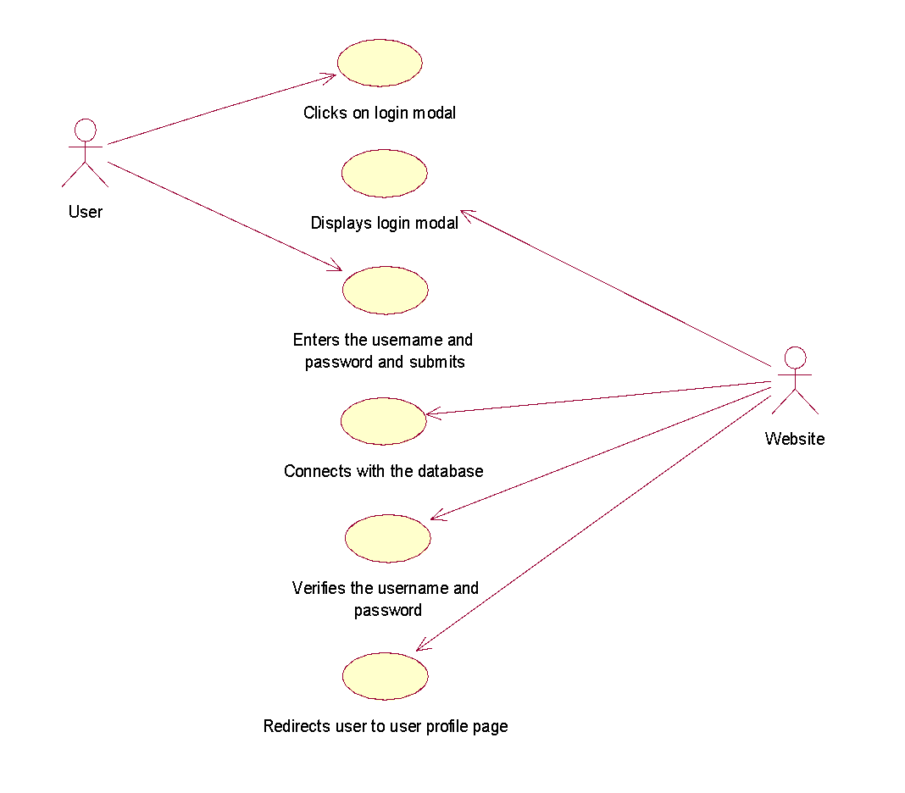

## USE CASE DIAGRAM: RGISTRATION MODAL

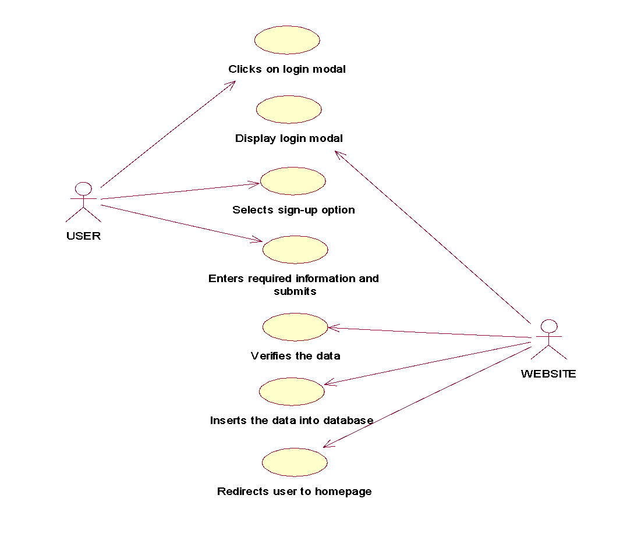

## USE CASE DIAGRAM: SUBMIT RECIPE

## 

## USE CASE DIAGRAM: TOOLBOX

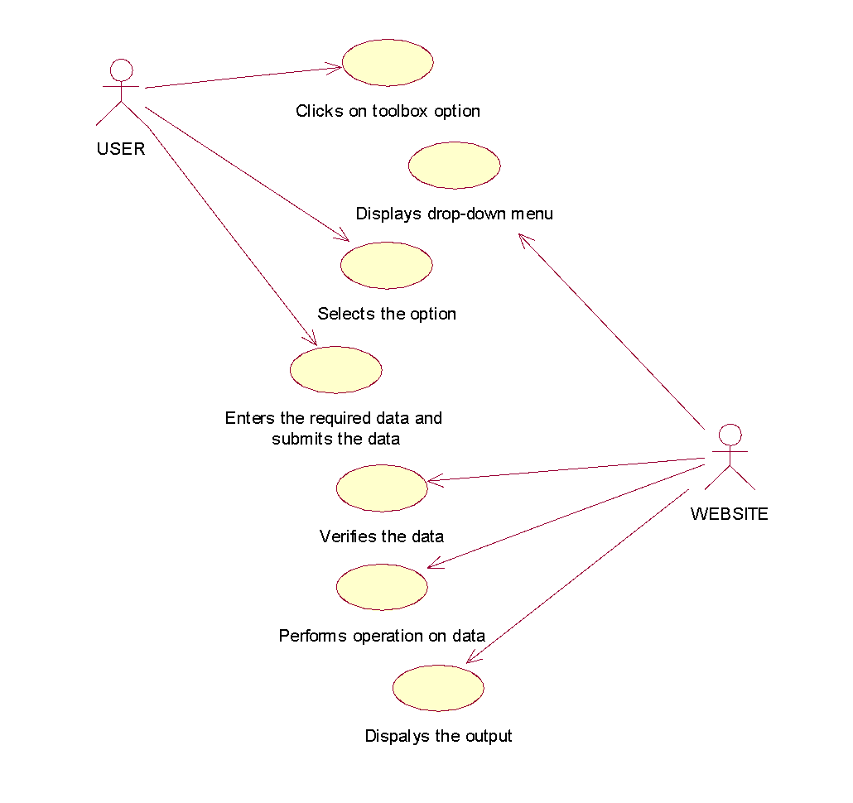



# PROJECT IMPLEMENTATION

# PROJECT IMPLEMENTATION

* The **User-Interface (UI)** of the website is been designed using **Bootstrap 3**.
* The **backend** is been coded using a programming language known as **PHP**.
* **“PhpMyAdmin”** has been used for database management and for storing data.
* To run/test the website local host is been used and is ran using **Apache server**.
* **XAMPP** application provides **“phpMyAdmin”** and **Apache server.**
* **PHP 5** has been used to code for backend while combination of HTML, CSS and Bootstrap is used to design UI.



# CODING AND SNAPSHOTS

# CODING AND SNAPSHOTS

## CODING

### index.php:

<?php

session_start();

//&& basename(__FILE__)!="index.php"

if(isset($_SESSION['username']))

{

die("<script>window.location='user_login.php';</script>");

}

?>

<!DOCTYPE html>

<html lang="en">

<head>

<title>Chef's Zone - The Culinary Specialist </title>

<meta charset="utf-8">

<meta name="viewport" content="width=device-width, initial-scale=1">

<link href='css/bootstrap.css' rel='stylesheet'>

<link href='css/style.css' rel='stylesheet'>

<link href="http://fonts.googleapis.com/css?family=Montserrat" rel="stylesheet" type="text/css">

<link href="http://fonts.googleapis.com/css?family=Lato" rel="stylesheet" type="text/css">

<link rel="stylesheet" href="http://maxcdn.bootstrapcdn.com/font-awesome/4.2.0/css/font-awesome.min.css">

<!-- Google Fonts -->

<link href='http://fonts.googleapis.com/css?family=Open+Sans:300,300italic,400,400italic,600,700' rel='stylesheet' type='text/css'>

<link href='http://fonts.googleapis.com/css?family=Raleway:400,500,600,700' rel='stylesheet' type='text/css'>

<!--link rel="stylesheet" type="text/css" href="//fonts.googleapis.com/css?family=Walter+Turncoat" /-->

<link rel="stylesheet" href="css/footer.css">

<link rel="stylesheet" href="http://maxcdn.bootstrapcdn.com/font-awesome/4.2.0/css/font-awesome.min.css">

<style>

</style>

</head>

<body background="images/2.jpg" style="background-repeat:no-repeat;">

<div class="top">

<div class="container">

<div class="row">

<div class="col-md-5">

<ul class="social pull-left">

<div class="slide">

<li><a href="404.php"><i class="fa fa-facebook"></i></a></li>

<li><a href="404.php"><i class="fa fa-twitter"></i></a></li>

<li><a href="404.php"><i class="fa fa-linkedin"></i></a></li>

<li><a href="404.php"><i class="fa fa-github"></i></a></li>

</div>

</ul><!-- /.social -->

</div><!-- /.col-md-5 -->

<div class="col-md-7">

<div class="user pull-right">

<div class="slide">

<a class="user" href="javascript:;" data-toggle="modal" data-target="#loginModal"> User Login</a>

</div>

</div><!-- /.user -->

</div><!-- /.col-md-7 -->

</div><!-- /.row -->

</div><!-- /.containter -->

</div><!-- /.top -->

<!-- Header -->

<header id="header" class="header">

<div class="header-wrap">

<div class="container">

<div class="row">

<div class="col-md-12">

<div class="logo-wrap">

<div id="logo" class="logo">

<a href="index.php" rel="home">

<img src="images/logo.png" style=" position: relative; bottom: 175px;right: 45px;">

</a>

</div>

</div>

<nav id="mainnav" class="mainnav">

<ul class="menu">

<li class="has-sub current"><a href="about.php">About Us</a></li>

<li class="has-sub"><a href="cuisine_type.php">Cuisines</a>

<ul class="sub-menu">

<li><a href="indian.php">Indian</a></li>

<li><a href="french.php">French</a></li>

<li><a href="italian.php">Italian</a></li>

<li><a href="mexican.php">Mexican</a></li>

<li><a href="chinese.php">Chinese</a></li>

<li><a href="thai.php">Thai</a></li>

<li><a href="japanese.php">Japanese</a></li>

<li><a href="spanish.php">Spanish</a></li>

</ul><!-- /.submenu -->

</li>

<li><a href="#" title="spacing" class="spacing" style="width:500px"></a></li>

<li class="has-sub"><a href="#">Tool Box</a>

<ul class="sub-menu">

<li><a data-toggle="modal" data-target="#myModal">Ingredients Converter</a></li>

<li><a data-toggle="modal" data-target="#myModal2">Langauge Translator</a></li>

</ul><!-- /.submenu -->

</li>

<li class="last"><a href="contact.php">Contact</a></li>

</ul><!-- /.menu -->

</nav><!-- /nav -->

</div><!-- /.col-md-12 -->

</div><!-- /.row -->

</div><!-- /.container -->

</div><!-- /.header-wrap -->

</header><!-- /.header -->

<br><br><br><br><br><br><br><br><br>

<div id="heading" class="slide">

<center><h1><font face="Anadalus" color="aliceblue">Welcome to<b><strong> CHEF'S ZONE</strong></b><br>The best in the Culinary Specialists</font></h1></center>

</div>

<br><br><br><br><br>

<div id="search">

<center>

<form method="post" action="main_search.php">

<input type="text" placeholder="Search for..." required="" name="main_name" style="width:50%;border-radius:5px;line-height: 4rem;font-size: 20px;padding-left: 15px;">

<button type="submit" class="btn btn-primary" style=" height: 46px; width: 100px; position: relative; top: -4px;">Search</button>

</form>

</center>

</div>

<br><br>

<!-- -Login Modal -->

<div class="modal fade" id="loginModal" role="dialog">

<div class="modal-dialog">

<div class="modal-content login-modal">

<div class="modal-header login-modal-header">

<button type="button" class="close" data-dismiss="modal" aria-label="Close"><span aria-hidden="true">&times;</span></button>

<h4 class="modal-title text-center" id="loginModalLabel">USER AUTHENTICATION</h4>

</div>

<div class="modal-body">

<div class="text-center">

<div role="tabpanel" class="login-tab">

<!-- Nav tabs -->

<ul class="nav nav-tabs" role="tablist">

<li role="presentation" class="active"><a id="signin-taba" href="#home" aria-controls="home" role="tab" data-toggle="tab">Sign In</a></li>

<li role="presentation"><a id="signup-taba" href="#profile" aria-controls="profile" role="tab" data-toggle="tab">Sign Up</a></li>

<li role="presentation"><a id="forgetpass-taba" href="#forget_password" aria-controls="forget_password" role="tab" data-toggle="tab">Forget Password</a></li>

</ul>

<!-- Tab panes -->

<div class="tab-content">

<div role="tabpanel" class="tab-pane active text-center" id="home">

&nbsp;&nbsp;

<span id="login_fail" class="response_error" style="display: none;">Login failed, please try again.</span>

<div class="clearfix"></div>

<form action="login/loginform.php" method="POST">

<div class="form-group">

<div class="input-group">

<div class="input-group-addon"><i class="fa fa-user"></i></div>

<input type="text" class="form-control" id="login_username" name="username" placeholder="Username" required>

</div>

<span class="help-block has-error" id="email-error"></span>

</div>

<div class="form-group">

<div class="input-group">

<div class="input-group-addon"><i class="fa fa-lock"></i></div>

<input type="password" class="form-control" id="password" name="password" placeholder="Password" required>

</div>

<span class="help-block has-error" id="password-error"></span>

</div>

<button type="submit" id="login_btn" class="btn btn-block bt-login" data-loading-text="Logging in....">Login</button>

<div class="clearfix"></div>

<div class="login-modal-footer">

<div class="row">

<div class="col-xs-8 col-sm-8 col-md-8">

<i class="fa fa-lock"></i>

<a href="javascript:;" class="forgetpass-tab"> Forgot password? </a>

</div>

<div class="col-xs-4 col-sm-4 col-md-4">

<i class="fa fa-check"></i>

<a href="javascript:;" class="signup-tab"> Sign Up </a>

</div>

</div>

</div>

</form>

</div>

<div role="tabpanel" class="tab-pane" id="profile">

&nbsp;&nbsp;

<span id="registration_fail" class="response_error" style="display: none;">Registration failed, please try again.</span>

<div class="clearfix"></div>

<form action="login/register.php" method="post">

<div class="form-group">

<div class="input-group">

<div class="input-group-addon"><i class="fa fa-user"></i></div>

<input type="text" class="form-control" name="username" id="username" placeholder="Username" required>

</div>

<span class="help-block has-error" data-error='0' id="username-error"></span>

</div>

<div class="form-group">

<div class="input-group">

<div class="input-group-addon"><i class="fa fa-lock"></i></div>

<input type="password" class="form-control" name="password" id="password" placeholder="Password" required>

</div>

<span class="help-block has-error" id="password-error"></span>

</div>

<div class="form-group">

<div class="input-group">

<div class="input-group-addon"><i class="fa fa-at"></i></div>

<input type="text" class="form-control" id="remail" name="email" placeholder="Email" required>

</div>

<span class="help-block has-error" data-error='0' id="remail-error"></span>

</div>

<button type="submit" id="register_btn" class="btn btn-block bt-login" data-loading-text="Registering....">Register</button>

<div class="clearfix"></div>

<div class="login-modal-footer">

<div class="row">

<div class="col-xs-8 col-sm-8 col-md-8">

<i class="fa fa-lock"></i>

<a href="javascript:;" class="forgetpass-tab"> Forgot password? </a>

</div>

<div class="col-xs-4 col-sm-4 col-md-4">

<i class="fa fa-check"></i>

<a href="javascript:;" class="signin-tab"> Sign In </a>

</div>

</div>

</div>

</form>

</div>

<div role="tabpanel" class="tab-pane text-center" id="forget_password">

&nbsp;&nbsp;

<span id="reset_fail" class="response_error" style="display: none;"></span>

<div class="clearfix"></div>

<form>

<div class="form-group">

<div class="input-group">

<div class="input-group-addon"><i class="fa fa-user"></i></div>

<input type="text" class="form-control" id="femail" placeholder="Email" required>

</div>

<span class="help-block has-error" data-error='0' id="femail-error"></span>

</div>

<button type="button" id="reset_btn" class="btn btn-block bt-login" data-loading-text="Please wait....">Forget Password</button>

<div class="clearfix"></div>

<div class="login-modal-footer">

<div class="row">

<div class="col-xs-6 col-sm-6 col-md-6">

<i class="fa fa-lock"></i>

<a href="javascript:;" class="signin-tab"> Sign In </a>

</div>

<div class="col-xs-6 col-sm-6 col-md-6">

<i class="fa fa-check"></i>

<a href="javascript:;" class="signup-tab"> Sign Up </a>

</div>

</div>

</div>

</form>

</div>

</div>

</div>

</div>

</div>

</div>

</div>

</div>

</div>

<!--Login module ends here-->

<!-- Modal 1 -->

<div class="modal fade" id="myModal" tabindex="-1" role="dialog" aria-labelledby="myModalLabel" aria-hidden="true">

<div class="modal-dialog">

<div class="modal-content">

<div class="modal-header">

<button type="button" class="close" data-dismiss="modal" aria-hidden="true">

<span class="glyphicon glyphicon-remove" aria-hidden="true"></span>

</button>

</div>

<div class="modal1-body">

<iframe src="ing.php" id="info" class="iframe" name="info" seamless="" height="100%" width="100%"></iframe>

</div>

</div>

</div>

</div> <!-- /#myModal -->

<!-- Modal 2 -->

<div class="modal fade" id="myModal2" tabindex="-1" role="dialog" aria-labelledby="myModalLabel" aria-hidden="true">

<div class="modal-dialog">

<div class="modal-content">

<div class="modal-header">

<button type="button" class="close" data-dismiss="modal" aria-hidden="true">

<span class="glyphicon glyphicon-remove" aria-hidden="true"></span>

</button>

</div>

<div class="modal1-body">

<iframe src="translate.php" id="info" class="iframe" name="info" seamless="" height="100%" width="100%"></iframe>

</div>

</div>

</div>

</div> <!-- /#myModal -->

<!--CATEGORIES-->

<div class="container-fluid" style="background-color:#f6f6f6; font-family:Anadalus;" >

<div class=" text-center">

<div class="row">

<h1 style="text-align:center; font-family:anadalus; color:#330000;">CATEGORIES</h1>

<div class="col-md-6 " role="tabpanel" style="width:100%;background-color:#F6F6F6;">

<!-- Nav tabs -->

<ul class="nav nav-justified" id="nav-tabs" role="tablist">

<li role="presentation">

<a href="#breakfast" aria-controls="breakfast" role="tab" data-toggle="tab">

<img src="images/breakfast.jpg">

</a>

</li>

<li role="presentation">

<a href="#lunch" aria-controls="lunch" role="tab" data-toggle="tab">

<img src="images/lunch.jpg">

</a>

</li>

<li role="presentation">

<a href="#dinner" aria-controls="dinner" role="tab" data-toggle="tab">

<img src="images/dinner.jpg">

</a>

</li>

</ul>

<!-- Tab panes -->

<div class="tab-content" id="tabs-collapse">

<div role="tabpanel" class="tab-pane fade" id="breakfast">

<div class="tab-inner">

<p><strong class="lead"><a href="breakfast.php">BREAKFAST</a></strong></p>

<p class="text-uppercase">All Happiness Depends on a Leisurely Breakfast!!</p>

</div>

</div>

<div role="tabpanel" class="tab-pane fade in active" id="lunch">

<div class="tab-inner">

<p><strong class="lead"><a href="lunch.php">LUNCH</a></strong></p>

<p class="text-uppercase">Lunch is for wimps!!</p>

</div>

</div>

<div role="tabpanel" class="tab-pane fade" id="dinner">

<div class="tab-inner">

<p><strong class="lead"><a href="dinner.php">DINNER</a></strong></p>

<p class="text-uppercase">A good dinner and feasting reconciles everyone!!</p>

</div>

</div>

</div>

</div>

</div>

<div class="row">

<div class="col-md-6 " role="tabpanel" style="width:100%;background-color:#F6F6F6;">

<!-- Nav tabs -->

<ul class="nav nav-justified" id="nav-tabs" role="tablist">

<li role="presentation">

<a href="#snacks" aria-controls="snacks" role="tab" data-toggle="tab">

<img src="images/snacks.jpg">

</a>

</li>

<li role="presentation">

<a href="#starters" aria-controls="starters" role="tab" data-toggle="tab">

<img src="images/starters.jpg">

</a>

</li>

<li role="presentation">

<a href="#dessert" aria-controls="dessert" role="tab" data-toggle="tab">

<img src="images/dessert.jpg">

</a>

</li>

</ul>

<!-- Tab panes -->

<div class="tab-content" id="tabs-collapse">

<div role="tabpanel" class="tab-pane fade" id="snacks">

<div class="tab-inner">

<p><strong class="lead"><a href="snacks.php">SNACKS</a></strong></p>

<p class="text-uppercase">Bigger snacks bigger slacks!!</p>

</div>

</div>

<div role="tabpanel" class="tab-pane fade in active" id="starters">

<div class="tab-inner">

<p><strong class="lead"><a href="starters.php">STARTERS</a></strong></p>

<p class="text-uppercase">Always cook decilious starters because first impression is the last impression!!</p>

</div>

</div>

<div role="tabpanel" class="tab-pane fade" id="dessert">

<div class="tab-inner">

<p><strong class="lead"><a href="dessert.php">DESSERT</a></strong></p>

<p class="text-uppercase">A balanced diet is having a cupcake in each hand!!</p>

</div>

</div>

</div>

</div>

</div>

</div>

<div class="container-fluid bg-grey">

<div class=" text-center">

<div class="row">

<h1 style="text-align:center; font-family:anadalus; color:#330000;">TODAY'S SPECIAL</h1>

</div>

</div>

<br>

<?php

include "config.php";

if(!$conn)

{

echo "Error : ".mysql_error($conn);

//display error if connetion is not set

}

//Part 1

else

{

include "random.php";

$id=gen_num();

//echo "Id New : ".$id."<br>";

if($id==-1)

{

echo "Error 1<br>";

//add header

}

else

{

$sql = "SELECT * FROM cuisines WHERE id='$id'";

$result = $conn->query($sql);

if ($result->num_rows > 0)

{

// output data of each row

while($row = $result->fetch_assoc())

{

/*

display results according to

"Filtered Value Of Column : ID"

Stored in Array Named $Value

*/

$target=$row["icon"];

$target='uploads/'.$target.'.jpeg';

?>

<div class="col-sm-4"><image src="<?php echo $target;?>" height="80%" width="80%" style="padding-top:25px;"></div>

<div class="col-sm-8" style="font-family:sans-serif;">

<h2><?php echo ucwords($row["name"]);?></h2>

<?php

echo "<b>Categories : </b>".ucwords($row["category"])."<br>";

echo "<b>Recipe Type : </b>".ucwords($row["sub_category"])."<br>";

$time=$row["cook_time"];

$hours = floor($time/60);

$minutes = $time%60;

if ($hours==0 && $minutes==0)

{

header("Location: 404.php");

}

if ($hours==0 && $minutes!=0)

{

echo "<b>Time : </b>".$minutes." mins<br>";

}

if ($hours!=0 && $minutes==0)

{

echo "<b>Time : </b>".$hours." hr<br>";

}

if ($hours!=0 && $minutes!=0)

{

echo "<b>Time : </b>".$hours." hr ".$minutes." min <br>";

}

?>

<p><?php echo $row["description"]; ?> </p>

<form action="single_cuisine.php" method="POST">

<button type="submit" class="btn btn-primary btn-sm" role="button" name="recipe_name" value="<?php echo $row["id"];?>" style="width:100px; font-size:15px;">See More</button>

</form>

<?php

}

}

else

{

echo "Error : 2";

}

}

}

$conn->close();

?>

</div>

<div class="col-sm-3"></div>

</div>

</div>

<!--/start-footer-->

<footer class="footer-distributed">

<div class="footer-left">

<h1>Chef's<span>Zone</span></h1>

<p class="footer-links">

<a href="index.php">HOME</a>

·

<a href="cuisine_type.php">CATEGORIES</a>

·

<a href="about.php">ABOUT US</a>

·

<a href="contact.php">CONTACT US</a>

</p>

<p class="footer-company-name">&copy;CHEF'S ZONE 2015</p>

</div>

<div class="footer-center">

<div>

<i class="fa fa-map-marker"></i>

<p><span>Mumbai, India.</span></p>

</div>

<div>

<i class="fa fa-phone"></i>

<p>+91 9892639557 </p>

</div>

<div>

<i class="fa fa-envelope"></i>

<p><a href="mailto:chefszone@gmail.com">support@chefszone.com</a></p>

</div>

</div>

<div class="footer-right">

<p class="footer-company-about">

<span>About CHEF'S ZONE</span>

CHEF’S ZONE is a newly developed website based on recipes you want to search.

CHEF’S ZONE offers Indian cooks at all skill level a dynamic and indispensable

place to discover and share food online.

</p>

<div class="footer-icons">

<a href="404.php"><i class="fa fa-facebook"></i></a>

<a href="404.php"><i class="fa fa-twitter"></i></a>

<a href="404.php"><i class="fa fa-linkedin"></i></a>

<a href="404.php"><i class="fa fa-github"></i></a>

</div>

</div>

</footer>

<script src="https://ajax.googleapis.com/ajax/libs/jquery/1.11.1/jquery.min.js"></script>

<script type="text/javascript" src="https://code.jquery.com/jquery-2.1.1.min.js"></script>

<script>

$('.multi-field-wrapper').each(function()

{

var $wrapper = $('.multi-fields', this);

$(".add-field", $(this)).click(function(e)

{

$('.multi-field:first-child', $wrapper).clone(true).appendTo($wrapper).find('input').val('').focus();

});

$('.multi-field .remove-field', $wrapper).click(function()

{

if ($('.multi-field', $wrapper).length > 1)

$(this).parent('.multi-field').remove();

});

});

</script>

<script>

$('.multi-field-wrapper').each(function() {

var $wrapper = $('.multi-fields', this);

$(".add-field1", $(this)).click(function(e) {

$('.multi-field:first-child', $wrapper).clone(true).appendTo($wrapper).find('input').val('').focus();

});

$('.multi-field .remove-field', $wrapper).click(function() {

if ($('.multi-field', $wrapper).length > 1)

$(this).parent('.multi-field').remove();

});

});

</script>

<script src="http://maxcdn.bootstrapcdn.com/bootstrap/3.3.5/js/bootstrap.min.js"></script>

<script>

$(document).ready(function()

{

// Add smooth scrolling to all links in navbar + footer link

$(".navbar a, footer a[href='#myPage']").on('click', function(event)

{

// Prevent default anchor click behavior

event.preventDefault();

// Store hash

var hash = this.hash;

// Using jQuery's animate() method to add smooth page scroll

// The optional number (900) specifies the number of milliseconds it takes to scroll to the specified area

$('html, body').animate(

{

scrollTop: $(hash).offset().top

}, 900, function()

{

// Add hash (#) to URL when done scrolling (default click behavior)

window.location.hash = hash;

});

});

// Slide in elements on scroll

$(window).scroll(function()

{

$(".slideanim").each(function()

{

var pos = $(this).offset().top;

var winTop = $(window).scrollTop();

if (pos < winTop + 600)

{

$(this).addClass("slide");

}

});

});

})

//modal call

$(document).ready(function()

{

$(document).on('click','.signup-tab',function(e)

{

e.preventDefault();

$('#signup-taba').tab('show');

});

$(document).on('click','.signin-tab',function(e)

{

e.preventDefault();

$('#signin-taba').tab('show');

});

$(document).on('click','.forgetpass-tab',function(e)

{

e.preventDefault();

$('#forgetpass-taba').tab('show');

});

});

</script>

</body>

</html>

### indian.php:

<?php

session_start();

?>

<!DOCTYPE html>

<html lang="en">

<head>

<title>Chef's Zone - The Culinary Specialist </title>

<meta charset="utf-8">

<meta name="viewport" content="width=device-width, initial-scale=1">

<link href='css/bootstrap.css' rel='stylesheet'>

<link href='css/style.css' rel='stylesheet'>

<link href="http://fonts.googleapis.com/css?family=Montserrat" rel="stylesheet" type="text/css">

<link href="http://fonts.googleapis.com/css?family=Lato" rel="stylesheet" type="text/css">

<script src="https://ajax.googleapis.com/ajax/libs/jquery/1.11.1/jquery.min.js"></script>

<script src="http://maxcdn.bootstrapcdn.com/bootstrap/3.3.5/js/bootstrap.min.js"></script>

<!-- Google Fonts -->

<link href='http://fonts.googleapis.com/css?family=Open+Sans:300,300italic,400,400italic,600,700' rel='stylesheet' type='text/css'>

<link href='http://fonts.googleapis.com/css?family=Raleway:400,500,600,700' rel='stylesheet' type='text/css'>

<link rel="stylesheet" href="css/footer.css">

<link rel="stylesheet" href="http://maxcdn.bootstrapcdn.com/font-awesome/4.2.0/css/font-awesome.min.css">

</head>

<body background="images/2.jpg">

<div class="top">

<div class="container">

<div class="row">

<div class="col-md-5">

<ul class="social pull-left">

<div class="slide">

<li><a href="404.php"><i class="fa fa-facebook"></i></a></li>

<li><a href="404.php"><i class="fa fa-twitter"></i></a></li>

<li><a href="404.php"><i class="fa fa-linkedin"></i></a></li>

<li><a href="404.php"><i class="fa fa-github"></i></a></li>

</div>

</ul><!-- /.social -->

</div><!-- /.col-md-5 -->

<div class="col-md-7">

<?php

//&& basename(__FILE__)!="index.php"

if(isset($_SESSION['username'])==TRUE)

{

?>

<div class="user pull-right">

<div class="slide">

<a href="logout.php">Logout</a>

</div>

</div><!-- /.user -->

<div class="user pull-right">

<div class="slide">

<a class="user" href="update_profile.php">Update Profile</a>

</div>

</div><!-- /.user -->

<?php

}

else

{

?>

<div class="user pull-right">

<div class="slide">

<a class="user" href="javascript:;" data-toggle="modal" data-target="#loginModal"> User Login</a>

</div>

</div>

<?php

}

?>

</div><!-- /.col-md-7 -->

</div><!-- /.row -->

</div><!-- /.containter -->

</div><!-- /.top -->

<!-- Header -->

<header id="header" class="header">

<div class="header-wrap">

<div class="container">

<div class="row">

<div class="col-md-12">

<div class="logo-wrap">

<div id="logo" class="logo">

<a href="index.php" rel="home">

<img src="images/logo.png" style=" position: relative; bottom: 175px;right: 45px;">

</a>

</div>

</div>

<nav id="mainnav" class="mainnav">

<ul class="menu">

<li class="has-sub current"><a href="about.php">About Us</a></li>

<li class="has-sub"><a href="cuisine_type.php">Cuisines</a>

<ul class="sub-menu">

<li><a href="indian.php">Indian</a></li>

<li><a href="french.php">French</a></li>

<li><a href="italian.php">Italian</a></li>

<li><a href="mexican.php">Mexican</a></li>

<li><a href="chinese.php">Chinese</a></li>

<li><a href="thai.php">Thai</a></li>

<li><a href="japanese.php">Japanese</a></li>

<li><a href="spanish.php">Spanish</a></li>

</ul><!-- /.submenu -->

</li>

<li><a href="#" title="spacing" class="spacing" style="width:500px"></a></li>

<li class="has-sub"><a href="#">Tool Box</a>

<ul class="sub-menu">

<li><a data-toggle="modal" data-target="#myModal">Ingredients Converter</a></li>

<li><a data-toggle="modal" data-target="#myModal2">Langauge Translator</a></li>

</ul><!-- /.submenu -->

</li>

<li class="last"><a href="contact.php">Contact</a>

</li>

</ul><!-- /.menu -->

</nav><!-- /nav -->

</div><!-- /.col-md-12 -->

</div><!-- /.row -->

</div><!-- /.container -->

</div><!-- /.header-wrap -->

</header><!-- /.header -->

<!-- -Login Modal -->

<div class="modal fade" id="loginModal" role="dialog">

<div class="modal-dialog">

<div class="modal-content login-modal">

<div class="modal-header login-modal-header">

<button type="button" class="close" data-dismiss="modal" aria-label="Close"><span aria-hidden="true">&times;</span></button>

<h4 class="modal-title text-center" id="loginModalLabel">USER AUTHENTICATION</h4>

</div>

<div class="modal-body">

<div class="text-center">

<div role="tabpanel" class="login-tab">

<!-- Nav tabs -->

<ul class="nav nav-tabs" role="tablist">

<li role="presentation" class="active"><a id="signin-taba" href="#home" aria-controls="home" role="tab" data-toggle="tab">Sign In</a></li>

<li role="presentation"><a id="signup-taba" href="#profile" aria-controls="profile" role="tab" data-toggle="tab">Sign Up</a></li>

<li role="presentation"><a id="forgetpass-taba" href="#forget_password" aria-controls="forget_password" role="tab" data-toggle="tab">Forget Password</a></li>

</ul>

<!-- Tab panes -->

<div class="tab-content">

<div role="tabpanel" class="tab-pane active text-center" id="home">

&nbsp;&nbsp;

<span id="login_fail" class="response_error" style="display: none;">Login failed, please try again.</span>

<div class="clearfix"></div>

<form action="login/loginform.php" method="POST">

<div class="form-group">

<div class="input-group">

<div class="input-group-addon"><i class="fa fa-user"></i></div>

<input type="text" class="form-control" id="login_username" name="username" placeholder="Username" required>

</div>

<span class="help-block has-error" id="email-error"></span>

</div>

<div class="form-group">

<div class="input-group">

<div class="input-group-addon"><i class="fa fa-lock"></i></div>

<input type="password" class="form-control" id="password" name="password" placeholder="Password" required>

</div>

<span class="help-block has-error" id="password-error"></span>

</div>

<button type="submit" id="login_btn" class="btn btn-block bt-login" data-loading-text="Logging in....">Login</button>

<div class="clearfix"></div>

<div class="login-modal-footer">

<div class="row">

<div class="col-xs-8 col-sm-8 col-md-8">

<i class="fa fa-lock"></i>

<a href="javascript:;" class="forgetpass-tab"> Forgot password? </a>

</div>

<div class="col-xs-4 col-sm-4 col-md-4">

<i class="fa fa-check"></i>

<a href="javascript:;" class="signup-tab"> Sign Up </a>

</div>

</div>

</div>

</form>

</div>

<div role="tabpanel" class="tab-pane" id="profile">

&nbsp;&nbsp;

<span id="registration_fail" class="response_error" style="display: none;">Registration failed, please try again.</span>

<div class="clearfix"></div>

<form action="login/register.php" method="post">

<div class="form-group">

<div class="input-group">

<div class="input-group-addon"><i class="fa fa-user"></i></div>

<input type="text" class="form-control" name="username" id="username" placeholder="Username" required>

</div>

<span class="help-block has-error" data-error='0' id="username-error"></span>

</div>

<div class="form-group">

<div class="input-group">

<div class="input-group-addon"><i class="fa fa-lock"></i></div>

<input type="password" class="form-control" name="password" id="password" placeholder="Password" required>

</div>

<span class="help-block has-error" id="password-error"></span>

</div>

<div class="form-group">

<div class="input-group">

<div class="input-group-addon"><i class="fa fa-at"></i></div>

<input type="text" class="form-control" id="remail" name="email" placeholder="Email" required>

</div>

<span class="help-block has-error" data-error='0' id="remail-error"></span>

</div>

<button type="submit" id="register_btn" class="btn btn-block bt-login" data-loading-text="Registering....">Register</button>

<div class="clearfix"></div>

<div class="login-modal-footer">

<div class="row">

<div class="col-xs-8 col-sm-8 col-md-8">

<i class="fa fa-lock"></i>

<a href="javascript:;" class="forgetpass-tab"> Forgot password? </a>

</div>

<div class="col-xs-4 col-sm-4 col-md-4">

<i class="fa fa-check"></i>

<a href="javascript:;" class="signin-tab"> Sign In </a>

</div>

</div>

</div>

</form>

</div>

<div role="tabpanel" class="tab-pane text-center" id="forget_password">

&nbsp;&nbsp;

<span id="reset_fail" class="response_error" style="display: none;"></span>

<div class="clearfix"></div>

<form>

<div class="form-group">

<div class="input-group">

<div class="input-group-addon"><i class="fa fa-user"></i></div>

<input type="text" class="form-control" id="femail" placeholder="Email" required>

</div>

<span class="help-block has-error" data-error='0' id="femail-error"></span>

</div>

<button type="button" id="reset_btn" class="btn btn-block bt-login" data-loading-text="Please wait....">Forget Password</button>

<div class="clearfix"></div>

<div class="login-modal-footer">

<div class="row">

<div class="col-xs-6 col-sm-6 col-md-6">

<i class="fa fa-lock"></i>

<a href="javascript:;" class="signin-tab"> Sign In </a>

</div>

<div class="col-xs-6 col-sm-6 col-md-6">

<i class="fa fa-check"></i>

<a href="javascript:;" class="signup-tab"> Sign Up </a>

</div>

</div>

</div>

</form>

</div>

</div>

</div>

</div>

</div>

</div>

</div>

</div>

</div>

<!--Login module ends here-->

<!-- Modal 1 -->

<div class="modal fade" id="myModal" tabindex="-1" role="dialog" aria-labelledby="myModalLabel" aria-hidden="true">

<div class="modal-dialog">

<div class="modal-content">

<div class="modal-header">

<button type="button" class="close" data-dismiss="modal" aria-hidden="true">

<span class="glyphicon glyphicon-remove" aria-hidden="true"></span>

</button>

</div>

<div class="modal1-body">

<iframe src="ing.php" id="info" class="iframe" name="info" seamless="" height="100%" width="100%"></iframe>

</div>

</div>

</div>

</div> <!-- /#myModal -->

<!-- Modal 2 -->

<div class="modal fade" id="myModal2" tabindex="-1" role="dialog" aria-labelledby="myModalLabel" aria-hidden="true">

<div class="modal-dialog">

<div class="modal-content">

<div class="modal-header">

<button type="button" class="close" data-dismiss="modal" aria-hidden="true">

<span class="glyphicon glyphicon-remove" aria-hidden="true"></span>

</button>

</div>

<div class="modal1-body">

<iframe src="translate.php" id="info" class="iframe" name="info" seamless="" height="100%" width="100%"></iframe>

</div>

</div>

</div>

</div> <!-- /#myModal -->

<!--start-gallery-->

<br><br>

<div class="gallery" id="gallery">

<div class="container-fluid" style="background-color: rgba(240, 248, 255, 0.86);">

<div class="tittle-head">

</div>

<div class="ourhistory">

<h3>About Indian Recipes</h3>

<p>Indian cuisine encompasses a wide variety of regional cuisines native to India. Given the range of diversity in soil type,

climate, culture, ethnic group and occupations, these cuisines vary significantly from each other and use locally available

spices, herbs, vegetables and fruits. Indian food is also heavily influenced by religious and cultural choices and traditions.

There has also been Central Asian influence on North Indian cuisine from the years of Mughal rule.

Indian cuisine has been and is still evolving, as a result of the nation's cultural interactions with other societies.</p>

<p>Historical incidents such as foreign invasions, trade relations and colonialism have also played a role in introducing certain foods

to the country.

For instance, the potato, a staple of the Indian diet, was brought to India by the Portuguese, who also introduced chillies and breadfruit.

Indian cuisine has also shaped the history of international relations; the spice trade between India and Europe is often cited by historians

as the primary

catalyst for Europe's Age of Discovery.

Spices were bought from India and traded around Europe and Asia.

It has also influenced other cuisines across the world, especially those from Southeast Asia, the British Isles, Fiji, and the Caribbean.</p>

</div><br>

<h2>Indian Recipes</h2>

<!--start-->

<!--PHP START-->

<?php

$flag=0;

$j=0;

$value=array();

include "config.php";

if(!$conn)

{

echo "Error : ".mysql_error($conn); //display error if connetion is not set

}

//Part 1

else

{

$sql = "SELECT * FROM cuisines WHERE category='indian'";

$result = $conn->query($sql);

if ($result->num_rows > 0)

{

// output data of each row

$i=1;

while($row = $result->fetch_assoc())

{

/*

display results according to

"Filtered Value Of Column : ID"

Stored in Array Named $Value

*/

$target=$row["icon"];

$target='uploads/'.$target.'.jpeg';

//$uploader=$row["uploader"];

//$uploader='uploads/'.$uploader.'.jpeg';

?>

<div class="col-sm-6 col-md-3">

<div class="panel panel-default panel-card">

<div class="panel-heading">

<img src="<?php echo $target;?>" />

<form action="single_cuisine.php" method="POST">

<button type="submit" class="btn btn-primary btn-sm" role="button" name="recipe_name" value="<?php echo $row["id"];?>">See More</button>

</form>

</div>

<div class="panel-figure">

<img class="img-responsive img-circle" src="images/login.png">

</div>

<div class="panel-body text-center">

<h4 class="panel-header"><?php echo ucwords($row["name"])."<br>";?></h4>

<small>A short description goes here.</small>

</div>

<div class="panel-thumbnails">

<div class="row">

<div class="col-xs-3">

<?php

echo "<center>Serves <br> <b>".$row["serves"]."</b></center><br>";

?>

</div>

<div class="col-xs-6">

<?php

$time=$row["cook_time"];

$hours = floor($time/60);

$minutes = $time%60;

if ($hours==0 && $minutes==0)

{

header("Location: 404.php");

}

if ($hours==0 && $minutes!=0)

{

echo "<center>Time <br><b> ".$minutes." mins </b></center><br>";

}

if ($hours!=0 && $minutes==0)

{

echo "<center>Time <br><b> ".$hours." hr </b></center><br>";

}

if ($hours!=0 && $minutes!=0)

{

echo "<center>Time <br><b> ".$hours." hr ".$minutes." min </b></center><br>";

}

?>

</div>

<div class="col-xs-3">

<?php

echo "<center>Views <br> <b>".$row["views"]."</b></center><br>";

?>

</div>

</div>

</div>

</div>

</div>

<?php

}

?>

<div class="col-sm-6 col-md-3">

<div class="panel panel-default panel-card">

<div class="panel-heading">

<img src="uploads/alt.jpeg" />

<form action="submit_recipe.php" method="POST">

<button type="submit" class="btn btn-primary btn-sm" role="button" name="recipe_name" value="<?php echo $row["id"];?>">Add</button>

</form>

</div>

<div class="panel-figure">

<img class="img-responsive img-circle" src="images/login.png">

</div>

<div class="panel-body text-center">

<h4 class="panel-header">Submit your Recipe</h4>

<small>A short description goes here.</small>

</div>

<div class="panel-thumbnails">

<div class="row">

<div class="col-xs-4">

</div>

<div class="col-xs-4">

</div>

<div class="col-xs-4">

</div>

</div>

</div>

</div>

</div>

<?php

}

else

{

?>

<div class="col-sm-6 col-md-3">

<div class="panel panel-default panel-card">

<div class="panel-heading">

<img src="<?php echo $target;?>" />

<form action="submit_recipe.php" method="POST">

<button type="submit" class="btn btn-primary btn-sm" role="button" name="recipe_name" value="<?php echo $row["id"];?>">Add</button>

</form>

</div>

<div class="panel-figure">

<img class="img-responsive img-circle" src="images/login.png" />

</div>

<div class="panel-body text-center">

<h4 class="panel-header">Submit your Recipe</h4>

<small>A short description goes here.</small>

</div>

<div class="panel-thumbnails">

<div class="row">

<div class="col-xs-4">

<i class="fa fa-envelope"></i>

<p><a href="mailto:chefszone@gmail.com">support@chefszone.com</a></p>

</div>

</div>

<div class="footer-right">

<p class="footer-company-about">

<span>About CHEF'S ZONE</span>

CHEF’S ZONE is a newly developed website based on recipes you want to search.

CHEF’S ZONE offers Indian cooks at all skill level a dynamic and indispensable

place to discover and share food online.

</p>

<div class="footer-icons">

<a href="404.php"><i class="fa fa-facebook"></i></a>

<a href="404.php"><i class="fa fa-twitter"></i></a>

<a href="404.php"><i class="fa fa-linkedin"></i></a>

<a href="404.php"><i class="fa fa-github"></i></a>

</div>

</div>

</footer>

<script src="https://ajax.googleapis.com/ajax/libs/jquery/1.11.1/jquery.min.js"></script>

<script src="http://maxcdn.bootstrapcdn.com/bootstrap/3.3.5/js/bootstrap.min.js"></script>

<script>

$(document).ready(function()

{

// Add smooth scrolling to all links in navbar + footer link

$(".navbar a, footer a[href='#myPage']").on('click', function(event) {

// Prevent default anchor click behavior

event.preventDefault();

// Store hash

var hash = this.hash;

// Using jQuery's animate() method to add smooth page scroll

// The optional number (900) specifies the number of milliseconds it takes to scroll to the specified area

$('html, body').animate({

scrollTop: $(hash).offset().top

}, 900, function()

{

// Add hash (#) to URL when done scrolling (default click behavior)

window.location.hash = hash;

});

});

// Slide in elements on scroll

$(window).scroll(function() {

$(".slideanim").each(function(){

var pos = $(this).offset().top;

var winTop = $(window).scrollTop();

if (pos < winTop + 600)

{

$(this).addClass("slide");

}

});

});

})

//modal call

$(document).ready(function(){

$(document).on('click','.signup-tab',function(e){

e.preventDefault();

$('#signup-taba').tab('show');

});

$(document).on('click','.signin-tab',function(e){

e.preventDefault();

$('#signin-taba').tab('show');

});

$(document).on('click','.forgetpass-tab',function(e){

e.preventDefault();

$('#forgetpass-taba').tab('show');

});

});

</script>

</body>

</html>

### main_search.php:

<?php

session_start();

?>

<!DOCTYPE html>

<html lang="en">

<head>

<title>Chef's Zone - The Culinary Specialist </title>

<meta charset="utf-8">

<meta name="viewport" content="width=device-width, initial-scale=1">

<link href='css/bootstrap.css' rel='stylesheet'>

<link href='css/style.css' rel='stylesheet'>

<link href="http://fonts.googleapis.com/css?family=Montserrat" rel="stylesheet" type="text/css">

<link href="http://fonts.googleapis.com/css?family=Lato" rel="stylesheet" type="text/css">

<script src="https://ajax.googleapis.com/ajax/libs/jquery/1.11.1/jquery.min.js"></script>

<script src="http://maxcdn.bootstrapcdn.com/bootstrap/3.3.5/js/bootstrap.min.js"></script>

<!-- Google Fonts -->

<link href='http://fonts.googleapis.com/css?family=Open+Sans:300,300italic,400,400italic,600,700' rel='stylesheet' type='text/css'>

<link href='http://fonts.googleapis.com/css?family=Raleway:400,500,600,700' rel='stylesheet' type='text/css'>

<link rel="stylesheet" href="css/footer.css">

<link rel="stylesheet" href="http://maxcdn.bootstrapcdn.com/font-awesome/4.2.0/css/font-awesome.min.css">

<div class="slider-bottom text-center">

<div class="container-fluid" style="background-color: rgba(240, 248, 255, 0.86);">

<div class="events-info">

<br>

<h3 class="wow fadeInLeft animated" data-wow-delay="0.4s">Recipes By Name</h3>

<h4>You Have Searched :

<span style="color : #BB8B44;">

<?php

$flag=0;

$j=0;

$value=array();

//Get Input

if (isset($_POST["main_name"])) //..................ing name

{

$name=strtolower($_POST["main_name"]);

echo ucwords($name);

include "config.php";

if(!$conn)

{

header("Location:404.php"); //redirect if connection not created

}

else

{

?>

</span>

</h4>

<div class="event-grids">

<!-------------------------name------------------------------>

<?php

//Part 1

$sql = "SELECT * FROM cuisines";

$result = $conn->query($sql);

if ($result->num_rows > 0)

{

// output data of each row

while($row = $result->fetch_assoc())

{

$str = $row["name"];

$ans=explode(" ",$str);

for($i=0;$i<count($ans);$i++)

{

if($ans[$i]==$name)

{

$value[$j]=$row["id"];

$j++;

}

}

}

}

else

{

header("Location:404.php"); //result not found for part 1 SQL statement

}

//Part 2

if (count($value)==0)

{

echo "<script>alert('Recipe not found by Name.');</script>";

}

else

{

//Search Result

?>

<form action="single_cuisine.php" method="POST">

<?php

for($i=0;$i<count($value);$i++)

{

$sql = "SELECT * FROM cuisines WHERE id='$value[$i]'";

$result = $conn->query($sql);

if ($result->num_rows > 0)

{

// output data of each row

while($row = $result->fetch_assoc())

{

$target=$row["icon"];

$target='uploads/'.$target.'.jpeg';

?>

<div class="col-sm-6 col-md-3">

<div class="panel panel-default panel-card">

<div class="panel-heading">

<img src="<?php echo $target;?>" />

<form action="single_cuisine.php" method="POST">

<button type="submit" class="btn btn-primary btn-sm" role="button" name="recipe_name" value="<?php echo $row["id"];?>">See More</button>

</form>

</div>

<div class="panel-figure">

<img class="img-responsive img-circle" src="images/login.png">

</div>

<div class="panel-body text-center">

<h4 class="panel-header"><?php echo ucwords($row["name"])."<br>";?></h4>

<small>A short description goes here.</small>

</div>

<div class="panel-thumbnails">

<div class="row">

<div class="col-xs-3">

<?php

echo "<center>Serves <br> <b>".$row["serves"]."</b></center><br>";

?>

</div>

<div class="col-xs-6">

<?php

$time=$row["cook_time"];

$hours = floor($time/60);

$minutes = $time%60;

if ($hours==0 && $minutes==0)

{

header("Location: 404.php");

}

if ($hours==0 && $minutes!=0)

{

echo "<center>Time <br><b> ".$minutes." mins </b></center><br>";

}

if ($hours!=0 && $minutes==0)

{

echo "<center>Time <br><b> ".$hours." hr </b></center><br>";

}

if ($hours!=0 && $minutes!=0)

{

echo "<center>Time <br><b> ".$hours." hr ".$minutes." min </b></center><br>";

}

?>

</div>

<div class="col-xs-3">

<?php

echo "<center>Views <br> <b>".$row["views"]."</b></center><br>";

?>

</div>

</div>

</div>

</div>

</div>

<?php

}

}

else

{

header("Location:404.php"); //result not found for part 2 SQL statement

}

}

}

?>

</form>

<?php

$conn->close();

}

}

else

{?>

<div class="col-sm-6 col-md-3">

<div class="panel panel-default panel-card">

<div class="panel-heading">

<img src="uploads/alt.jpeg">

<form action="submit_recipe.php" method="POST">

<button type="submit" class="btn btn-primary btn-sm" role="button" name="recipe_name" value="<?php echo $row["id"];?>">Add</button>

</form>

</div>

<div class="panel-figure">

<img class="img-responsive img-circle" src="images/login.png">

</div>

<div class="panel-body text-center">

<h4 class="panel-header">Submit your Recipe</h4>

<small>A short description goes here.</small>

</div>

<div class="panel-thumbnails">

<div class="row">

<div class="col-xs-4">

</div>

<div class="col-xs-4">

</div>

<div class="col-xs-4">

</div>

</div>

</div>

</div>

</div><?php

}

?><!---------------------end------------------>

<!--After Final Display Adjust Height Of "ADD A RECIIPE" Card-->

<div class="col-sm-6 col-md-3">

<div class="panel panel-default panel-card">

<div class="panel-heading">

<img src="uploads/alt.jpeg">

<form action="submit_recipe.php" method="POST">

<button type="submit" class="btn btn-primary btn-sm" role="button" name="recipe_name" value="<?php echo $row["id"];?>">Add</button>

</form>

</div>

<div class="panel-figure">

<img class="img-responsive img-circle" src="images/login.png">

</div>

<div class="panel-body text-center">

<h4 class="panel-header">Submit your Recipe</h4>

<small>A short description goes here.</small>

</div>

<div class="panel-thumbnails">

<div class="row">

<div class="col-xs-4">

</div>

<div class="col-xs-4">

</div>

<div class="col-xs-4">

</div>

</div>

</div>

</div>

</div>

<div class="clearfix"></div>

</div>

</div>

</div>

<!------------------------------------ing----------------------------------------------->

<div class="slider-bottom text-center">

<div class="container-fluid" style="background-color: rgba(240, 248, 255, 0.86);">

<div class="events-info">

<br>

<h3 class="wow fadeInLeft animated" data-wow-delay="0.4s">Recipes By Ingredients.</h3>

<h4>You Have Searched :

<span style="color : #BB8B44;">

<?php

$flag=0;

$j=0;

$value=array();

//Get Input

if (isset($_POST["main_name"])) //..................ing name

{

$name=strtolower($_POST["main_name"]);

//echo "name :".$name."<br><br>";

echo ucwords($name);

$serverName = "localhost"; //server name

$userName = "root"; //username phpmyadmin

$pass = "root"; //password for database

$dbName = "chefszone"; //database name

// to connect database

$conn = mysqli_connect($serverName,$userName,$pass,$dbName);

if(!$conn)

{

header("Location:404.php"); //redirect if connection not created

}

else

{

?>

</span>

</h4>

<div class="event-grids">

<!-------------------------name------------------------------>

<?php

//Part 1

$sql = "SELECT * FROM cuisines";

$result = $conn->query($sql);

if ($result->num_rows > 0)

{

// output data of each row

while($row = $result->fetch_assoc())

{

$str = $row["ingredients"];

$ans=explode(",",$str);

//echo "<br><br>";

for($i=0;$i<count($ans);$i++)

{

//echo "Ans :".$ans[$i]."<br>";

if($ans[$i]==$name)

{

$value[$j]=$row["id"];

//echo "Value : ".$value."<br>";

$j++;

}

}

}

}

else

{

header("Location:404.php"); //result not found for part 1 SQL statement

}

//Part 2

if (count($value)==0)

{

echo "<script>alert('Recipe not found by Ingredients.');</script>";

}

else

{

//Search Result

?>

<form action="single_cuisine.php" method="POST">

<?php

for($i=0;$i<count($value);$i++)

{

$sql = "SELECT * FROM cuisines WHERE id='$value[$i]'";

$result = $conn->query($sql);

if ($result->num_rows > 0)

{

// output data of each row

while($row = $result->fetch_assoc())

{

$target=$row["icon"];

$target='uploads/'.$target.'.jpeg';

?>

<div class="col-sm-6 col-md-3">

<div class="panel panel-default panel-card">

<div class="panel-heading">

<img src="<?php echo $target;?>" />

<form action="single_cuisine.php" method="POST">

<button type="submit" class="btn btn-primary btn-sm" role="button" name="recipe_name" value="<?php echo $row["id"];?>">See More</button>

</form>

</div>

<div class="panel-figure">

<img class="img-responsive img-circle" src="images/login.png">

</div>

<div class="panel-body text-center">

<h4 class="panel-header"><?php echo ucwords($row["name"])."<br>";?></h4>

<small>A short description goes here.</small>

</div>

<div class="panel-thumbnails">

<div class="row">

<div class="col-xs-3">

<?php

echo "<center>Serves <br> <b>".$row["serves"]."</b></center><br>";

?>

</div>

<div class="col-xs-6">

<?php

$time=$row["cook_time"];

$hours = floor($time/60);

$minutes = $time%60;

if ($hours==0 && $minutes==0)

{

header("Location: 404.php");

}

if ($hours==0 && $minutes!=0)

{

echo "<center>Time <br><b> ".$minutes." mins </b></center><br>";

}

if ($hours!=0 && $minutes==0)

{

echo "<center>Time <br><b> ".$hours." hr </b></center><br>";

}

if ($hours!=0 && $minutes!=0)

{

echo "<center>Time <br><b> ".$hours." hr ".$minutes." min </b></center><br>";

}

?>

</div>

<div class="col-xs-3">

<?php

echo "<center>Views <br> <b>".$row["views"]."</b></center><br>";

?>

</div>

</div>

</div>

</div>

</div>

<?php

}

}

else

{

header("Location:404.php"); //result not found for part 2 SQL statement

}

}

}

?>

</form>

<?php

$conn->close();

}

}

else

{?>

<div class="col-sm-6 col-md-3">

<div class="panel panel-default panel-card">

<div class="panel-heading">

<img src="uploads/alt.jpeg" />

<form action="submit_recipe.php" method="POST">

<button type="submit" class="btn btn-primary btn-sm" role="button" name="recipe_name" value="<?php echo $row["id"];?>">Add</button>

</form>

</div>

<div class="panel-figure">

<img class="img-responsive img-circle" src="images/login.png">

</div>

<div class="panel-body text-center">

<h4 class="panel-header">Submit your Recipe</h4>

<small>A short description goes here.</small>

</div>

<div class="panel-thumbnails">

<div class="row">

<div class="col-xs-4">

</div>

<div class="col-xs-4">

<a href="index.php">HOME</a>

·

<a href="single_cuisine.php">CATEGORIES</a>

·

<a href="contact.php">CONTACT US</a>

·

<a href="about.php">ABOUT US</a>

</p>

<p class="footer-company-name">&copy;CHEF'S ZONE 2015</p>

</div>

<div class="footer-center">

<div>

<i class="fa fa-map-marker"></i>

<p><span>Mumbai, India.</span></p>

</div>

<div>

<i class="fa fa-phone"></i>

<p>+91 9892639557 </p>

</div>

<div>

<i class="fa fa-envelope"></i>

<p><a href="mailto:chefszone@gmail.com">support@chefszone.com</a></p>

</div>

</div>

<div class="footer-right">

<p class="footer-company-about">

<span>About CHEF'S ZONE</span>

CHEF’S ZONE is a newly developed website based on recipes you want to search.

CHEF’S ZONE offers Indian cooks at all skill level a dynamic and indispensable

place to discover and share food online.

</p>

<div class="footer-icons">

<a href="404.php"><i class="fa fa-facebook"></i></a>

<a href="404.php"><i class="fa fa-twitter"></i></a>

<a href="404.php"><i class="fa fa-linkedin"></i></a>

<a href="404.php"><i class="fa fa-github"></i></a>

</div>

</div>

</footer>

<script src="https://ajax.googleapis.com/ajax/libs/jquery/1.11.1/jquery.min.js"></script>

<script src="http://maxcdn.bootstrapcdn.com/bootstrap/3.3.5/js/bootstrap.min.js"></script>

<script>

$(document).ready(function()

{

// Add smooth scrolling to all links in navbar + footer link

$(".navbar a, footer a[href='#myPage']").on('click', function(event) {

// Prevent default anchor click behavior

event.preventDefault();

// Store hash

var hash = this.hash;

// Using jQuery's animate() method to add smooth page scroll

// The optional number (900) specifies the number of milliseconds it takes to scroll to the specified area

$('html, body').animate({

scrollTop: $(hash).offset().top

}, 900, function()

{

// Add hash (#) to URL when done scrolling (default click behavior)

window.location.hash = hash;

});

});

// Slide in elements on scroll

$(window).scroll(function() {

$(".slideanim").each(function(){

var pos = $(this).offset().top;

var winTop = $(window).scrollTop();

if (pos < winTop + 600)

{

$(this).addClass("slide");

}

});

});

})

//modal call

$(document).ready(function(){

$(document).on('click','.signup-tab',function(e){

e.preventDefault();

$('#signup-taba').tab('show');

});

$(document).on('click','.signin-tab',function(e){

e.preventDefault();

$('#signin-taba').tab('show');

});

$(document).on('click','.forgetpass-tab',function(e){

e.preventDefault();

$('#forgetpass-taba').tab('show');

});

});

</script>

</body>

</html>

### Single_cuisine.php:

<!--PHP START-->

<?php

$flag=0;

$j=0;

$value=array();

include "config.php";

if(!$conn)

{

echo "Error : ".mysql_error($conn); //display error if connetion is not set

}

//Part 1

else

{

$ref=$_POST["recipe_name"];

//echo "id : ".$ref;

$sql = "SELECT views FROM cuisines WHERE id='$ref'";

$result = $conn->query($sql);

if ($result->num_rows > 0) {

// output data of each row

while($row = $result->fetch_assoc()) {

$view=$row["views"];

//echo "View :".$view;

$view++;

//echo "View :".$view;

}

} else {

echo "0 results";

}

$sql = "UPDATE cuisines SET views='$view' WHERE id='$ref'";

if ($conn->query($sql) === FALSE) {

echo "Error updating record: " . $conn->error;

}

$sql = "SELECT * FROM cuisines WHERE id='$ref'";

$result = $conn->query($sql);

if ($result->num_rows > 0)

{

// output data of each row

$i=1;

while($row = $result->fetch_assoc())

{

$target=$row["icon"];

$target='uploads/'.$target.'.jpeg';

?>

<div class="single">

<div class="container" style="background-color: rgba(240, 248, 255, 0.86); width:1375px; margin-top:15px;">

<div class="single-grids">

<div class="col-md-4 single-grid">

<div class="flexslider">

<ul class="slides">

<li data-thumb="<?php echo $target;?>">

<div class="thumb-image"> <img src="<?php echo $target;?>" data-imagezoom="true" class="img-responsive"> </div>

</li>

<li data-thumb="<?php echo $target;?>">

<div class="thumb-image"> <img src="<?php echo $target;?>" data-imagezoom="true" class="img-responsive"> </div>

</li>

<li data-thumb="<?php echo $target;?>">

<div class="thumb-image"> <img src="<?php echo $target;?>" data-imagezoom="true" class="img-responsive"> </div>

</li>

</ul>

</div>

</div>

<div class="col-md-4 single-grid simpleCart_shelfItem">

<h3><?php echo ucwords($row["name"]);?></h3>

<p><?php echo $row["description"];?></p>

<div class="clearfix"></div>

<?php

function like_recipe()

{

//echo "id : ".$ref;

$like=$row["likes"];

//echo "View :".$view;

$like++;

//echo "View :".$view;

$sql = "UPDATE cuisines SET likes='$like' WHERE id='$ref'";

if ($conn->query($sql) === FALSE) {

echo "Error updating record: " . $conn->error;

}

else

{

echo "<script>alert('Liked');</script>";

}

}

?>

<div class="tag">

<p>Category : <?php echo ucwords($row["category"]);?></p>

<p>Views : <?php echo $row["views"];?></p>

<?php

$time=$row["cook_time"];

$hours = floor($time/60);

$minutes = $time%60;

if ($hours==0 && $minutes==0)

{

header("Location: 404.php");

}

if ($hours==0 && $minutes!=0)

{

echo "Time: ".$minutes." mins <br>";

}

if ($hours!=0 && $minutes==0)

{

echo "Time: ".$hours." hr<br>";

}

if ($hours!=0 && $minutes!=0)

{

echo "Time: ".$hours." hr ".$minutes." min <br>";

}

?>

</div>

</div>

<div class="col-md-4 single-grid1">

<h2>Most Searched Recipes</h2>

<?php

$sql_view = "SELECT * FROM cuisines ORDER BY views DESC LIMIT 3;";

$result_view = $conn->query($sql_view);

if ($result_view->num_rows > 0) {

// output data of each row

while($row_view = $result_view->fetch_assoc()) {

?><ul>

<li><?php echo ucwords($row_view["name"]);?></li>

<form action='single_cuisine.php' method='POST'>

<button type='submit' name='recipe_name' value='<?php echo $row_view['id'];?>'>More</button>

</form>

<br>

</ul>

<?php

// echo ucwords($row["name"])." Views : ".$row["views"]."<br>";

}

} else {

echo "0 results";

}?><br>

<h2>Recently Added Recipes</h2>

<?php

$sql_view = "SELECT * FROM cuisines ORDER BY id DESC LIMIT 3;";

$result_view = $conn->query($sql_view);

if ($result_view->num_rows > 0) {

// output data of each row

while($row_view = $result_view->fetch_assoc()) {

?><ul>

<li><?php echo ucwords($row_view["name"]);?></li>

<form action='single_cuisine.php' method='POST'>

<button type='submit' name='recipe_name' value='<?php echo $row_view['id'];?>'>More</button>

</form>

<br>

</ul>

<?php

// echo ucwords($row["name"])." Views : ".$row["views"]."<br>";

}

} else {

echo "0 results";

}?>

</div>

<div class="clearfix"> </div>

</div>

</div>

</div>

<div class="container" style="background-color: rgba(240, 248, 255, 0.86);width:1375px;">

<section class="directions-components main-unit">

<!-- Components -->

<div class="col-md-4">

<h2 class="page-section-title">

Ingredients </h2>

<div class="components-container">

<section class="components-group">

<ul class="components-list">

<?php

$str = $row["ing_quantity"];

$str1=$row["ingredients"];

$ans=explode(",",$str);

$ans1=explode(",",$str1);

for($i=0;$i<count($ans);$i++)

{

?>

<li class="components-item" itemprop="ingredients">

<?php echo $ans[$i]." ".ucwords($ans1[$i]);

?> </li><?php

}

?>

</li>

</ul>

</section>

</div>

</div>

<!-- Directions -->

<div class="col-md-8">

<h2 class="page-section-title">

Directions </h2>

<section class="directions-group">

<ol class="directions-list">

<?php

$str = $row["steps"];

$ans=explode("^",$str);

for($i=0;$i<count($ans);$i++)

{

?>

<li class="directions-item">

<p class="directions-item-text">

<?php echo ucwords($ans[$i]);

?> </li><?php

}

?>

</ol>

</section>

</div>

</section>

</div>

<?php

}

}

}

?>

### Submit_recipe.php:

<div class="single">

<div class="container-fluid">

<div class="single-grids">

<div class="col-md-8 single-grid simpleCart_shelfItem">

<div class="col-xs-12">

<div class="project project-default" style="background-color:rgba(240, 248, 255, 0.86);">

<div class="project-content" >

<h3 class="lead">

Recipe Title

</h3>

<p>

<form method="post" action="submit_recipe_insert.php" enctype="multipart/form-data">

<!-- TITLE -->

<div class="form-group">

<label class="col-md-12 control-label" for="passwordinput">Recipe Title (Max 50 Characters) </label>

<div class="col-md-12">

<input id="passwordinput" name="title" type="text" placeholder="Enter Value" class="form-control input-md">

</div>

</div>

<hr>

<br><br><br><br>

<!-- CATEGORY -->

<div class="form-group">

<label class="col-md-2 control-label" for="selectbasic">Category</label>

<div class="col-md-6">

<select id="selectbasic" name="category" class="form-control">

<option disabled selected >Empty</option>

<option value="indian">Indian</option>

<option value="french">French</option>

<option value="Italian">Italian</option>

<option value="Mexican">Mexican</option>

<option value="Chinese">Chinese</option>

<option value="Thai">Thai</option>

<option value="japanese">Japanese</option>

<option value="spanish">Spanish</option>

</select>

</div>

<div class="col-md-4"></div>

</div>

<br><br>

<!-- SUBCATEGORY -->

<div class="form-group">

<label class="col-md-2 control-label" for="selectbasic">Sub Category</label>

<div class="col-md-6">

<select id="selectbasic" name="sub_category" class="form-control">

<option disabled selected >Empty</option>

<option value="breakfast">Breakfast</option>

<option value="lunch">Lunch</option>

<option value="dinner">Dinner</option>

<option value="snacks">Snacks</option>

<option value="starters">Starters</option>

<option value="dessert">Dessert</option>

</select>

</div>

<div class="col-md-4"></div>

</div>

<br><br>

<!-- Upload Image-->

<div class="form-group">

<label class="col-md-2 control-label" for="selectbasic">Select Image to Upload</label>

<div class="col-md-10">

<input type="file" name="fileToUpload" id="fileToUpload" style="width:50%">

</div>

</div>

<br><br><br>

<!--Short Summary -->

<div class="form-group">

<label class="col-md-12 control-label" for="passwordinput">Description (Max 5000 characters) </label>

<div class="col-md-12">

<div class="media-body">

<div class="form-group">

<textarea class="form-control" placeholder="Write a short description about your recipe..." style="height:110px" name="description"></textarea>

</div>

</div>

</div>

</div>

<!-- Ingredients Input -->

<div class="form-group">

<label class="col-md-12 control-label" for="passwordinput">Add Ingredients </label>

<table width="100%">

<tr>

<td>

<label class="col-md-5 control-label" for="passwordinput">Name</label>

</td>

<td>

<label class="col-md-5 control-label" for="passwordinput">Quantity </label>

</td>

</tr>

</table>

<div class="multi-field-wrapper">

<div class="multi-fields">

<div class="multi-field">

<div class="col-xs-5">

<input type="text" class="form-control" name="ing_name[]" />

</div>

<div class="col-xs-5">

<input type="text" class="form-control" name="ing_val[]" />

</div>

<button type="button" class="remove-field" style="width:9%; !important">Remove</button>

</div>

</div>

<br>

<center>

<button type="button" class="add-field">Add field</button>

</center>

</div>

</div>

<!-- Add Recpie -->

<div class="form-group">

<label class="col-md-12 control-label" for="passwordinput">Add Recipe </label>

<div class="multi-field-wrapper">

<div class="multi-fields">

<div class="multi-field">

<div class="form-group">

<div class="col-md-10">

<textarea class="form-control" name="steps[]" placeholder="Add Steps" style="height:110px"></textarea>

<!--<input type="textarea" class="form-control" placeholder="Add Steps" style="height:110px">-->

</div>

</div>

<br><br><br>

<button type="button" class="remove-field" style="width:9%; !important">Remove</button>

</div>

</div>

<br><br>

<center>

<button type="button" class="add-field">Add field</button>

</center>

</div>

</div>

<!-- Servings -->

<div class="form-group">

<label class="col-md-2 control-label" for="selectbasic">Serves</label>

<div class="col-md-2">

<input id="passwordinput" name="serves" type="text" placeholder="Enter Value" class="form-control input-md">

</div>

<div class="col-md-8">people</div>

</div>

<br><br>

<!-- SEASON -->

<div class="form-group">

<label class="col-md-2 control-label" for="selectbasic">Season</label>

<div class="col-md-6">

<select id="selectbasic" name="season" class="form-control">

<option disabled selected >Choose your season</option>

<option value="summer">Summer</option>

<option value="rainy">Rainy</option>

<option value="winter">Winter</option>

<option value="spring">Spring</option>

<option value="autumn">Autumn</option>

<option value="all">All</option>

</select>

</div>

<div class="col-md-4"></div>

</div>

<br><br>

<!-- Time Needed -->

<div class="form-group">

<label class="col-md-12 control-label" for="selectbasic">Cooking Time</label>

<div class="col-md-2">

<input id="passwordinput" name="hr" type="text" placeholder="Enter Value" class="form-control input-md">

</div>

<div class="col-md-1">hours</div>

<div class="col-md-2">

<input id="passwordinput" name="min" type="text" placeholder="Enter Value" class="form-control input-md">

</div>

<div class="col-md-1">minutes</div>

</div>

<br><br><br>

<input type="submit"><br><br>

</form>

</p>

</div>

</div>

</div>

</div>

<div class="col-md-4 single-grid1" style=" background:rgba(240, 248, 255, 0.86); border-radius: 15px; margin: 15px 0px;">

<h2 style="text-transform:none !important">Most Searched Recipes</h2>

<?php

include "config.php";

// Check connection

if ($conn->connect_error) {

die("Connection failed: " . $conn->connect_error);

}

$sql_view = "SELECT * FROM cuisines ORDER BY views DESC LIMIT 3;";

$result_view = $conn->query($sql_view);

if ($result_view->num_rows > 0) {

// output data of each row

while($row_view = $result_view->fetch_assoc()) {

?><ul>

<li><?php echo ucwords($row_view["name"]);?></li>

<form action='single_cuisine.php' method='POST'>

<button type='submit' name='recipe_name' value='<?php echo $row_view['id'];?>'>More</button>

</form>

<br>

</ul>

<?php

// echo ucwords($row["name"])." Views : ".$row["views"]."<br>";

}

} else {

echo "0 results";

}

?><br>

<h2>Recently Added Recipes</h2>

<?php

$sql_view = "SELECT * FROM cuisines ORDER BY id DESC LIMIT 3;";

$result_view = $conn->query($sql_view);

if ($result_view->num_rows > 0) {

// output data of each row

while($row_view = $result_view->fetch_assoc()) {

?><ul>

<li><?php echo ucwords($row_view["name"]);?></li>

<form action='single_cuisine.php' method='POST'>

<button type='submit' name='recipe_name' value='<?php echo $row_view['id'];?>'>More</button>

</form>

<br>

</ul>

<?php

// echo ucwords($row["name"])." Views : ".$row["views"]."<br>";

}

} else {

echo "0 results";

}?>

</div>

<div class="clearfix"> </div>

</div>

</div>

</div>

### Update_profile.php:

<?php

session_start();

?>

<!DOCTYPE html>

<html lang="en">

<head>

<title>Chef's Zone - The Culinary Specialist </title>

<meta charset="utf-8">

<meta name="viewport" content="width=device-width, initial-scale=1">

<link href='css/bootstrap.css' rel='stylesheet'>

<link href='css/style.css' rel='stylesheet'>

<script defer src="js/jquery.flexslider.js"></script>

<link rel="stylesheet" href="css/flexslider.css" type="text/css" media="screen" />

<link href="http://fonts.googleapis.com/css?family=Montserrat" rel="stylesheet" type="text/css">

<link href="http://fonts.googleapis.com/css?family=Lato" rel="stylesheet" type="text/css">

<script src="https://ajax.googleapis.com/ajax/libs/jquery/1.11.1/jquery.min.js"></script>

<script src="http://maxcdn.bootstrapcdn.com/bootstrap/3.3.5/js/bootstrap.min.js"></script>

<script type="text/javascript" src="https://code.jquery.com/jquery-2.1.1.min.js"></script>

<!-- Google Fonts -->

<link href='http://fonts.googleapis.com/css?family=Open+Sans:300,300italic,400,400italic,600,700' rel='stylesheet' type='text/css'>

<script src="js/imagezoom.js"></script>

<link href='http://fonts.googleapis.com/css?family=Raleway:400,500,600,700' rel='stylesheet' type='text/css'>

<link rel="stylesheet" href="css/footer.css">

<link rel="stylesheet" href="http://maxcdn.bootstrapcdn.com/font-awesome/4.2.0/css/font-awesome.min.css">

<script>

// Can also be used with $(document).ready()

$(window).load(function() {

$('.flexslider').flexslider({

animation: "slide",

controlNav: "thumbnails"

});

});

</script>

<!--//FlexSlider -->

<style>

/*----*/

.single-grids

{

padding: 4em 0;

}

.single-grid1 h2

{

margin-bottom: 0.5em;

margin-top: 1.5em;

text-align: center;

color: #5D4B33;

font-family: Marvel-Regular;

}

.single-grid1 ul li

{

list-style: none;

}

.single-grid1 ul li a:hover

{

color: #F07818;

}

.single-grid1 ul li a

{

font-size: 1em;

text-transform: capitalize;

line-height: 3em;

color: #999;

text-decoration: none;

}

p.qty

{

display: inline-block;

}

.single-grid #quantity

{

width: 50px;

height: 37px;

display: inline-block;

margin: 15px 10px 0 10px;

padding: 9px 0px 8px;

outline: none;

text-align: center;

}

.single-grid h3

{

font-size: 1.7em;

line-height: 1.6em;

color: #5D4B33;

margin-bottom: 0.5em;

font-family: 'Marvel-Regular';

}

.single-grid p

{

font-size: 1em;

line-height: 1.8em;

color: #999;

}

.single-grid h5

{

font-size: 1.5em;

color: #000;

}

span.glyphicon.glyphicon-star-empty:hover

{

color: red;

}

.btn_form a

{

outline: none;

display: inline-block;

font-size: 0.9em;

padding: 0.5em 1em;

border: 2px solid #F07818;

background: #F07818;

color: #fff;

text-transform: uppercase;

-webkit-transition: all 0.3s ease-in-out;

-moz-transition: all 0.3s ease-in-out;

-o-transition: all 0.3s ease-in-out;

transition: all 0.3s ease-in-out;

text-decoration: none;

margin-bottom: 1em;

}

.btn_form a:hover

{

background: transparent;

border-color: #5D4B33;

color:#5D4B33;

text-decoration: none;

}

ul.size li

{

display: inline-block;

margin: 0 10px 0 0;

}

ul.size h3

{

color: #F07818;

font-size: 1.4em;

text-transform: uppercase;

margin: 0 0 0.5em;

font-weight: 600;

}

ul.size li a

{

color: #999;

font-size: 1em;

background: #fff;

padding: 5px 0;

}

.recipeIngredients

{

float: left;

clear: none;

width: 65%;

}

.recipeDetail H2 SMALL

{

font-size: 1.4rem;

color: #7f838b;

}

h2

{

font-weight: 600;

font-size: 2.1rem;

line-height: 2.3rem;

}

h2 small

{

font-weight: 400;

color: #7f838b;

font-size: smaller;

}

.accent

{

color: #83b238;

}

.directions-components

{

background-color: #fff;

color: #666666;

font-family: Georgia,serif;

font-size: 16px;

font-size: 1rem;

line-height: 1.4;

letter-spacing: 0.4px;

letter-spacing: 0.025rem;

}

.page-section-title

{

line-height: 1.1;

border-bottom: 1px solid #171717;

padding-bottom: 0.07143em;

margin-bottom: 0.57143em;

}

.directions-components .directions-group, .directions-components .components-group

{

margin-bottom: 1.57143em;

}

.components-container > .components-group > .components-list

{

list-style-type: none;

margin: 0;

padding: 0;

}

.components-item, .directions-item

{

margin-bottom: 1em;

font-size:15px;

}

.directions-components .directions-group ol

{

margin: 0;

}

.shape{

border-style: solid; border-width: 0 70px 40px 0; float:right; height: 0px; width: 0px;

-ms-transform:rotate(360deg); /* IE 9 */

-o-transform: rotate(360deg); /* Opera 10.5 */

-webkit-transform:rotate(360deg); /* Safari and Chrome */

transform:rotate(360deg);

}

.shape-text{

color:#fff; font-size:12px; font-weight:bold; position:relative; right:-40px; top:2px; white-space: nowrap;

-ms-transform:rotate(30deg); /* IE 9 */

-o-transform: rotate(360deg); /* Opera 10.5 */

-webkit-transform:rotate(30deg); /* Safari and Chrome */

transform:rotate(30deg);

}

.project {

min-height:120px;

height:auto;

}

.project{

background: url(bg.jpg);; border:1px solid #ddd; box-shadow: 0 10px 20px rgba(0, 0, 0, 0.2); margin: 15px 0; overflow:hidden; text-align:center; border-radius:15px;

}

.project-radius{

border-radius:7px;

}

.project-default { border-color: #999999; }

.project-default .shape{

border-color: transparent #999999 transparent transparent;

border-color: rgba(255,255,255,0) #999999 rgba(255,255,255,0) rgba(255,255,255,0);

}

.project-danger { border-color: #d9534f; }

.project-danger .shape{

border-color: transparent #d9534f transparent transparent;

border-color: rgba(255,255,255,0) #d9534f rgba(255,255,255,0) rgba(255,255,255,0);

}

.project-success { border-color: #5cb85c; }

.project-success .shape{

border-color: transparent #5cb85c transparent transparent;

border-color: rgba(255,255,255,0) #5cb85c rgba(255,255,255,0) rgba(255,255,255,0);

}

.project-primary { border-color: #428bca; }

.project-primary .shape{

border-color: transparent #428bca transparent transparent;

border-color: rgba(255,255,255,0) #428bca rgba(255,255,255,0) rgba(255,255,255,0);

}

.project-info { border-color: #5bc0de; }

.project-info .shape{

border-color: transparent #5bc0de transparent transparent;

border-color: rgba(255,255,255,0) #5bc0de rgba(255,255,255,0) rgba(255,255,255,0);

}

.project-warning { border-color: #f0ad4e; }

.project-warning .shape{

border-color: transparent #f0ad4e transparent transparent;

border-color: rgba(255,255,255,0) #f0ad4e rgba(255,255,255,0) rgba(255,255,255,0);

}

.project-content {

padding:0 20px 10px;

}

input[type="submit"] {

border-color: #949494;

border-radius: 15px;

width: 35rem;

font-size: 2rem;

font-weight: 500;

}

button {

border-radius: 15px;

width: 26rem;

font-size: 17px;

font-weight: 500;

}

input#fileToUpload {

border-radius: 15px;

width: 29rem;

font-size: 18px;

font-weight: 500;

}

</style>

</head>

<body background="images/2.jpg">

<div class="top">

<div class="container">

<div class="row">

<div class="col-md-5">

<ul class="social pull-left">

<div class="slide">

<li><a href="404.php"><i class="fa fa-facebook"></i></a></li>

<li><a href="404.php"><i class="fa fa-twitter"></i></a></li>

<li><a href="404.php"><i class="fa fa-linkedin"></i></a></li>

<li><a href="404.php"><i class="fa fa-github"></i></a></li>

</div>

</ul><!-- /.social -->

</div><!-- /.col-md-5 -->

<div class="col-md-7">

<?php

//&& basename(__FILE__)!="index.php"

if(isset($_SESSION['username'])==TRUE)

{

?>

<div class="user pull-right">

<div class="slide">

<a href="logout.php">Logout</a>

</div>

</div><!-- /.user -->

<div class="user pull-right">

<div class="slide">

<a class="user" href="update_profile.php">Update Profile</a>

</div>

</div><!-- /.user -->

<?php

}

else

{

?>

<div class="user pull-right">

<div class="slide">

<a class="user" href="javascript:;" data-toggle="modal" data-target="#loginModal"> User Login</a>

</div>

</div>

<?php

}

?>

</div><!-- /.col-md-7 -->

</div><!-- /.row -->

</div><!-- /.containter -->

</div><!-- /.top -->

<!-- Header -->

<header id="header" class="header">

<div class="header-wrap">

<div class="container">

<div class="row">

<div class="col-md-12">

<div class="logo-wrap">

<div id="logo" class="logo">

<a href="index.php" rel="home">

<img src="images/logo.png" style=" position: relative; bottom: 175px;right: 45px;">

</a>

</div>

</div>

<nav id="mainnav" class="mainnav">

<ul class="menu">

<li class="has-sub current"><a href="about.php">About Us</a></li>

<li class="has-sub"><a href="cuisine_type.php">Cuisines</a>

<ul class="sub-menu">

<li><a href="indian.php">Indian</a></li>

<li><a href="french.php">French</a></li>

<li><a href="italian.php">Italian</a></li>

<li><a href="mexican.php">Mexican</a></li>

<li><a href="chinese.php">Chinese</a></li>

<li><a href="thai.php">Thai</a></li>

<li><a href="japanese.php">Japanese</a></li>

<li><a href="spanish.php">Spanish</a></li>

</ul><!-- /.submenu -->

</li>

<li><a href="#" title="spacing" class="spacing" style="width:500px"></a></li>

<li class="has-sub"><a href="#">Tool Box</a>

<ul class="sub-menu">

<li><a data-toggle="modal" data-target="#myModal">Ingredients Converter</a></li>

<li><a data-toggle="modal" data-target="#myModal2">Langauge Translator</a></li>

</ul><!-- /.submenu -->

</li>

<li class="last"><a href="contact.php">Contact</a></li>

</ul><!-- /.menu -->

</nav><!-- /nav -->

</div><!-- /.col-md-12 -->

</div><!-- /.row -->

</div><!-- /.container -->

</div><!-- /.header-wrap -->

</header><!-- /.header -->

<!-- -Login Modal -->

<div class="modal fade" id="loginModal" role="dialog">

<div class="modal-dialog">

<div class="modal-content login-modal">

<div class="modal-header login-modal-header">

<button type="button" class="close" data-dismiss="modal" aria-label="Close"><span aria-hidden="true">&times;</span></button>

<h4 class="modal-title text-center" id="loginModalLabel">USER AUTHENTICATION</h4>

</div>

<div class="modal-body">

<div class="text-center">

<div role="tabpanel" class="login-tab">

<!-- Nav tabs -->

<ul class="nav nav-tabs" role="tablist">

<li role="presentation" class="active"><a id="signin-taba" href="#home" aria-controls="home" role="tab" data-toggle="tab">Sign In</a></li>

<li role="presentation"><a id="signup-taba" href="#profile" aria-controls="profile" role="tab" data-toggle="tab">Sign Up</a></li>

<li role="presentation"><a id="forgetpass-taba" href="#forget_password" aria-controls="forget_password" role="tab" data-toggle="tab">Forget Password</a></li>

</ul>

<!-- Tab panes -->

<div class="tab-content">

<div role="tabpanel" class="tab-pane active text-center" id="home">

&nbsp;&nbsp;

<span id="login_fail" class="response_error" style="display: none;">Login failed, please try again.</span>

<div class="clearfix"></div>

<form action="login/loginform.php" method="POST">

<div class="form-group">

<div class="input-group">

<div class="input-group-addon"><i class="fa fa-user"></i></div>

<input type="text" class="form-control" id="login_username" name="username" placeholder="Username" required>

</div>

<span class="help-block has-error" id="email-error"></span>

</div>

<div class="form-group">

<div class="input-group">

<div class="input-group-addon"><i class="fa fa-lock"></i></div>

<input type="password" class="form-control" id="password" name="password" placeholder="Password" required>

</div>

<span class="help-block has-error" id="password-error"></span>

</div>

<button type="submit" id="login_btn" class="btn btn-block bt-login" data-loading-text="Logging in....">Login</button>

<div class="clearfix"></div>

<div class="login-modal-footer">

<div class="row">

<div class="col-xs-8 col-sm-8 col-md-8">

<i class="fa fa-lock"></i>

<a href="javascript:;" class="forgetpass-tab"> Forgot password? </a>

</div>

<div class="col-xs-4 col-sm-4 col-md-4">

<i class="fa fa-check"></i>

<a href="javascript:;" class="signup-tab"> Sign Up </a>

</div>

</div>

</div>

</form>

</div>

<div role="tabpanel" class="tab-pane" id="profile">

&nbsp;&nbsp;

<span id="registration_fail" class="response_error" style="display: none;">Registration failed, please try again.</span>

<div class="clearfix"></div>

<form action="login/register.php" method="post">

<div class="form-group">

<div class="input-group">

<div class="input-group-addon"><i class="fa fa-user"></i></div>

<input type="text" class="form-control" name="username" id="username" placeholder="Username" required>

</div>

<span class="help-block has-error" data-error='0' id="username-error"></span>

</div>

<div class="form-group">

<div class="input-group">

<div class="input-group-addon"><i class="fa fa-lock"></i></div>

<input type="password" class="form-control" name="password" id="password" placeholder="Password" required>

</div>

<span class="help-block has-error" id="password-error"></span>

</div>

<div class="form-group">

<div class="input-group">

<div class="input-group-addon"><i class="fa fa-at"></i></div>

<input type="text" class="form-control" id="remail" name="email" placeholder="Email" required>

</div>

<span class="help-block has-error" data-error='0' id="remail-error"></span>

</div>

<button type="submit" id="register_btn" class="btn btn-block bt-login" data-loading-text="Registering....">Register</button>

<div class="clearfix"></div>

<div class="login-modal-footer">

<div class="row">

<div class="col-xs-8 col-sm-8 col-md-8">

<i class="fa fa-lock"></i>

<a href="javascript:;" class="forgetpass-tab"> Forgot password? </a>

</div>

<div class="col-xs-4 col-sm-4 col-md-4">

<i class="fa fa-check"></i>

<a href="javascript:;" class="signin-tab"> Sign In </a>

</div>

</div>

</div>

</form>

</div>

<div role="tabpanel" class="tab-pane text-center" id="forget_password">

&nbsp;&nbsp;

<span id="reset_fail" class="response_error" style="display: none;"></span>

<div class="clearfix"></div>

<form>

<div class="form-group">

<div class="input-group">

<div class="input-group-addon"><i class="fa fa-user"></i></div>

<input type="text" class="form-control" id="femail" placeholder="Email" required>

</div>

<span class="help-block has-error" data-error='0' id="femail-error"></span>

</div>

<button type="button" id="reset_btn" class="btn btn-block bt-login" data-loading-text="Please wait....">Forget Password</button>

<div class="clearfix"></div>

<div class="login-modal-footer">

<div class="row">

<div class="col-xs-6 col-sm-6 col-md-6">

<i class="fa fa-lock"></i>

<a href="javascript:;" class="signin-tab"> Sign In </a>

</div>

<div class="col-xs-6 col-sm-6 col-md-6">

<i class="fa fa-check"></i>

<a href="javascript:;" class="signup-tab"> Sign Up </a>

</div>

</div>

</div>

</form>

</div>

</div>

</div>

</div>

</div>

</div>

</div>

</div>

</div>

<!--Login module ends here-->

<!-- Modal 1 -->

<div class="modal fade" id="myModal" tabindex="-1" role="dialog" aria-labelledby="myModalLabel" aria-hidden="true">

<div class="modal-dialog">

<div class="modal-content">

<div class="modal-header">

<button type="button" class="close" data-dismiss="modal" aria-hidden="true">

<span class="glyphicon glyphicon-remove" aria-hidden="true"></span>

</button>

</div>

<div class="modal1-body">

<iframe src="ing.php" id="info" class="iframe" name="info" seamless="" height="100%" width="100%"></iframe>

</div>

</div>

</div>

</div> <!-- /#myModal -->

<!-- Modal 2 -->

<div class="modal fade" id="myModal2" tabindex="-1" role="dialog" aria-labelledby="myModalLabel" aria-hidden="true">

<div class="modal-dialog">

<div class="modal-content">

<div class="modal-header">

<button type="button" class="close" data-dismiss="modal" aria-hidden="true">

<span class="glyphicon glyphicon-remove" aria-hidden="true"></span>

</button>

</div>

<div class="modal1-body">

<iframe src="translate.php" id="info" class="iframe" name="info" seamless="" height="100%" width="100%"></iframe>

</div>

</div>

</div>

</div> <!-- /#myModal -->

<div class="single">

<div class="container-fluid">

<div class="single-grids">

<div class="col-md-8 single-grid simpleCart_shelfItem">

<div class="col-xs-12">

<div class="project project-default" style="background-color:rgba(240, 248, 255, 0.86);">

<div class="project-content">

<h3 class="lead">

Update Profile

</h3>

<p>

<form method="post" action="update_profile_insert.php" enctype="multipart/form-data">

<!-- TITLE -->

<div class="form-group">

<label class="col-md-12 control-label" for="passwordinput">Your Name</label>

<div class="col-md-12">

<input id="passwordinput" name="username" type="text" placeholder="Enter your name" class="form-control input-md">

</div>

</div>

<hr>

<br><br><br>

<!-- Upload Image-->

<div class="form-group">

<label class="col-md-2 control-label" for="selectbasic">Upload Image</label>

<div class="col-md-10">

<input type="file" name="fileToUpload" id="fileToUpload" style="width:50%">

</div>

</div>

<br><br><br>

<!-- SUBCATEGORY -->

<div class="form-group">

<label class="col-md-2 control-label" for="selectbasic">Cooking Level</label>

<div class="col-md-6">

<select id="selectbasic" name="level" class="form-control">

<option disabled selected >Select your cooking level</option>

<option value="not rated">Not Rated</option>

<option value="beginner">Beginner</option>

<option value="intermediate">Intermediate</option>

<option value="experienced">Experienced</option>

<option value="professional">Professional</option>

</select>

</div>

<div class="col-md-4"></div>

</div>

<br><br>

<!-- How long have you been cooking-->

<div class="form-group">

<label class="col-md-2 control-label" for="selectbasic">Experience</label>

<div class="col-md-6">

<select id="selectbasic" name="experience" class="form-control">

<option disabled selected >Empty</option>

<option value="1yr">less than 1 year</option>

<option value="5yr">5 - 10 years</option>

<option value="10yr">10 - 15 years</option>

<option value="15yr">15 - 20 years</option>

<option value="20yr">20 + years</option>

</select>

</div>

<div class="col-md-4"></div>

</div>

<br><br>

<!--Short Summary -->

<div class="form-group">

<label class="col-md-12 control-label" for="passwordinput">About Me</label>

<div class="col-md-12">

<div class="media-body">

<div class="form-group">

<textarea class="form-control" placeholder="Write a short description about yourself..." style="height:110px" name="about"></textarea>

</div>

</div>

</div>

</div>

<input type="submit"><br><br>

</form>

</p>

</div>

</div>

</div>

</div>

</div>

<div class="col-md-4 single-grid1" style="background:rgba(240, 248, 255, 0.86);border-radius: 15px;margin-top: -40px;">

<h2>Most Searched Recipes</h2>

<?php

include "config.php";

// Check connection

if ($conn->connect_error) {

die("Connection failed: " . $conn->connect_error);

}

$sql_view = "SELECT * FROM cuisines ORDER BY views DESC LIMIT 3;";

$result_view = $conn->query($sql_view);

if ($result_view->num_rows > 0) {

// output data of each row

while($row_view = $result_view->fetch_assoc()) {

?><ul>

<li><?php echo ucwords($row_view["name"]);?></li>

<form action='single_cuisine.php' method='POST'>

<button type='submit' name='recipe_name' value='<?php echo $row_view['id'];?>'>More</button>

</form>

<br>

</ul>

<?php

// echo ucwords($row["name"])." Views : ".$row["views"]."<br>";

}

} else {

echo "0 results";

}?><br>

<h2>Recently Added Recipes</h2>

<?php

$sql_view = "SELECT * FROM cuisines ORDER BY id DESC LIMIT 3;";

$result_view = $conn->query($sql_view);

if ($result_view->num_rows > 0) {

// output data of each row

while($row_view = $result_view->fetch_assoc()) {

?><ul>

<li><?php echo ucwords($row_view["name"]);?></li>

<form action='single_cuisine.php' method='POST'>

<button type='submit' name='recipe_name' value='<?php echo $row_view['id'];?>'>More</button>

</form>

<br>

</ul>

<?php

// echo ucwords($row["name"])." Views : ".$row["views"]."<br>";

}

} else {

echo "0 results";

}?>

</div>

<div class="clearfix"> </div>

</div>

</div>

</div>

<!--/start-footer-->

<footer class="footer-distributed">

<div class="footer-left">

<h1>Chef's<span>Zone</span></h1>

<p class="footer-links">

<a href="index.php">HOME</a>

·

<a href="single_cuisine.php">CATEGORIES</a>

·

<a href="contact.php">CONTACT US</a>

·

<a href="about.php">ABOUT US</a>

</p>

<p class="footer-company-name">&copy;CHEF'S ZONE 2015</p>

</div>

<div class="footer-center">

<div>

<i class="fa fa-map-marker"></i>

<p><span>SVKM'S Shri Bhagubhai Mafatlal Polytechnic</span> Mumbai, India.</p>

</div>

<div>

<i class="fa fa-phone"></i>

<p>+91 9892639557 </p>

</div>

<div>

<i class="fa fa-envelope"></i>

<p><a href="mailto:chefszone@gmail.com">support@chefszone.com</a></p>

</div>

</div>

<div class="footer-right">

<p class="footer-company-about">

<span>About CHEF'S ZONE</span>

CHEF’S ZONE is a newly developed website based on recipes you want to search.

CHEF’S ZONE offers Indian cooks at all skill level a dynamic and indispensable

place to discover and share food online.

</p>

<div class="footer-icons">

<a href="404.php"><i class="fa fa-facebook"></i></a>

<a href="404.php"><i class="fa fa-twitter"></i></a>

<a href="404.php"><i class="fa fa-linkedin"></i></a>

<a href="404.php"><i class="fa fa-github"></i></a>

</div>

</div>

</footer>

<script src="https://ajax.googleapis.com/ajax/libs/jquery/1.11.1/jquery.min.js"></script>

<script type="text/javascript" src="https://code.jquery.com/jquery-2.1.1.min.js"></script>

<script>

$('.multi-field-wrapper').each(function()

{

var $wrapper = $('.multi-fields', this);

$(".add-field", $(this)).click(function(e)

{

$('.multi-field:first-child', $wrapper).clone(true).appendTo($wrapper).find('input').val('').focus();

});

$('.multi-field .remove-field', $wrapper).click(function()

{

if ($('.multi-field', $wrapper).length > 1)

$(this).parent('.multi-field').remove();

});

});

</script>

<script>

$('.multi-field-wrapper').each(function() {

var $wrapper = $('.multi-fields', this);

$(".add-field1", $(this)).click(function(e) {

$('.multi-field:first-child', $wrapper).clone(true).appendTo($wrapper).find('input').val('').focus();

});

$('.multi-field .remove-field', $wrapper).click(function() {

if ($('.multi-field', $wrapper).length > 1)

$(this).parent('.multi-field').remove();

});

});

</script>

<script src="http://maxcdn.bootstrapcdn.com/bootstrap/3.3.5/js/bootstrap.min.js"></script>

<script>

$(document).ready(function()

{

// Add smooth scrolling to all links in navbar + footer link

$(".navbar a, footer a[href='#myPage']").on('click', function(event)

{

// Prevent default anchor click behavior

event.preventDefault();

// Store hash

var hash = this.hash;

// Using jQuery's animate() method to add smooth page scroll

// The optional number (900) specifies the number of milliseconds it takes to scroll to the specified area

$('html, body').animate(

{

scrollTop: $(hash).offset().top

}, 900, function()

{

// Add hash (#) to URL when done scrolling (default click behavior)

window.location.hash = hash;

});

});

// Slide in elements on scroll

$(window).scroll(function()

{

$(".slideanim").each(function()

{

var pos = $(this).offset().top;

var winTop = $(window).scrollTop();

if (pos < winTop + 600)

{

$(this).addClass("slide");

}

});

});

})

//modal call

$(document).ready(function()

{

$(document).on('click','.signup-tab',function(e)

{

e.preventDefault();

$('#signup-taba').tab('show');

});

$(document).on('click','.signin-tab',function(e)

{

e.preventDefault();

$('#signin-taba').tab('show');

});

$(document).on('click','.forgetpass-tab',function(e)

{

e.preventDefault();

$('#forgetpass-taba').tab('show');

});

});

</script>

</body>

</html>

### Submit_recipe_insert.php:

<?php

include "config.php";

// Check connection

if ($conn->connect_error) {

die("Connection failed: " . $conn->connect_error);

}

if (isset($_POST["title"])) //..................name

{

$name=strtolower($_POST["title"]);

$test=str_replace(" ", "_", $name);

//echo "name : ".$name."<br>";

//echo "test : ".$test."<br>";

//echo ucwords($name);

}

else

{

echo "<script>alert('Enter Name');</script>";

}

if (isset($_POST["category"])) //..................cat

{

$cat=$_POST["category"];

//echo "cat : ".$cat."<br>";

}

else

{

echo "<script>alert('Enter Category');</script>";

}

if (isset($_POST["sub_category"])) //..................sub cat

{

$sub_cat=$_POST["sub_category"];

//echo "sub_cat : ".$sub_cat."<br>";

}

else

{

echo "<script>alert('Enter Sub-Category');</script>";

}

//upload

//$test=1;

$target_dir = "uploads/";

$target_file = $target_dir . basename($_FILES["fileToUpload"]["name"]);

echo $target_dir."<br>";

//echo $target_file."<br>";

$uploadOk = 1;

$imageFileType = pathinfo($target_file,PATHINFO_EXTENSION);

//echo $imageFileType."<br>";

// Check if image file is a actual image or fake image

if(isset($_POST["submit"])) {

$check = getimagesize($_FILES["fileToUpload"]["tmp_name"]);

if($check !== false) {

// echo "File is an image - " . $check["mime"] . ".";

$uploadOk = 1;

} else {

// echo "File is not an image.";

$uploadOk = 0;

}

}

// Allow certain file formats

if($imageFileType != "jpg" && $imageFileType != "png" && $imageFileType != "jpeg"

&& $imageFileType != "gif" ) {

echo "<script>alert('Sorry, only JPG, JPEG, PNG & GIF files are allowed.');</script>";

$uploadOk = 0;

}

// Check if $uploadOk is set to 0 by an error

if ($uploadOk == 0) {

$target='uploads/alt.jpeg';

$test='alt';

echo "<script>alert('Sorry, your file was not uploaded.');</script>";

// if everything is ok, try to upload file

}

if (move_uploaded_file($_FILES["fileToUpload"]["tmp_name"], $target_file)) {

$target=rename($target_file,'uploads/'.$test.'.jpeg');

//echo "<br><br>target".$target."<br><br>";

//echo "The file ". basename( $_FILES["fileToUpload"]["name"]). " has been uploaded.";

} else {

echo "<script>alert('Sorry, there was an error uploading your file.');</script>";

}

//end

if (isset($_POST["description"])) //..................descript

{

$descript=$_POST["description"];

}

else

{

echo "<script>alert('Enter Description');</script>";

}

//collect_val.php

$ing_name ="";

$i=0;

//echo "Ing Name<br>";

if(isset($_POST["ing_name"]) && empty($_POST["username"])){

foreach($_POST["ing_name"] as $key => $text_field_a){

$ing_name .= $text_field_a .",";

//echo "I : ".$i;

//echo "<br>$ing_name<br><br>";

$i++;

}

}

$ing_val ="";

$i=0;

//echo "Ing Name<br>";

if(isset($_POST["ing_val"]) && empty($_POST["username"])){

foreach($_POST["ing_val"] as $key => $text_field_a){

$ing_val .= $text_field_a .",";

//echo "I : ".$i;

//echo "<br>$ing_val<br><br>";

$i++;

}

$ing_val=strtolower($ing_val);

}

//end

$steps ="";

$i=0;

if(isset($_POST["steps"]) && empty($_POST["username"])){

foreach($_POST["steps"] as $key => $text_field_c){

$steps .= $text_field_c ."^";

//echo "I : ".$i;

//echo "<br>$capture_field_vals<br><br>";

$i++;

}

}

if (isset($_POST["serves"])) //..................serves

{

$serves=$_POST["serves"];

}

else

{

echo "<script>alert('Enter serves');</script>";

}

if (isset($_POST["season"])) //..................season

{

$season=$_POST["season"];

}

else

{

echo "<script>alert('Enter season');</script>";

}

if (isset($_POST["hr"])) //..................time > hr

{

$hr=$_POST["hr"];

if (isset($_POST["min"])) //..................time > min

{

$min=$_POST["min"];

$time=$hr*60+$min;

}

else

{

echo "<script>alert('Enter min');</script>";

}

}

else

{

echo "<script>alert('Enter hr');</script>";

}

$date=date("Y-m-d");

$sql = "INSERT INTO cuisines (name, category, sub_category, ingredients, ing_quantity,description,icon, season, cook_time,serves,date,steps)

VALUES ('$name', '$cat', '$sub_cat','$ing_name','$ing_val','$descript','$test','$season','$time','$serves','$date','$steps')";

if ($conn->query($sql) === TRUE) {

echo "<script>alert('New record created successfully');</script>";

header("Location: submit_recipe.php");

} else {

echo "Error: " . $sql . "<br>" . $conn->error;

}

$conn->close();

?>

Ing.php:

<!------------------------------------TASk LEFT : Set Format Of Result Being Displayed----------------------------------->

<html>

<head>

<style>

.error {color: #FF0000;}

</style>

</head>

<body>

<?php

include "config.php";

$result_dest="";

$nameErr="";

$nameCorr="";

$null_value="";

$flag=0;

$val_flag=0;

$valErr="";

$en=$fr=$mr=$hi=$gu="";

if(empty($_REQUEST["source"]))

{

$src="Empty";

$flag=1;

}

else

{

$src=$_REQUEST["source"];

}

if(empty($_REQUEST["text"]))

{

$flag=1;

$text="";

}

else

{

if(is_numeric($_REQUEST["text"]))

{

$val_flag=1;

$flag=1;

}

else

{

$text=strtolower($_REQUEST["text"]);

}

}

if($flag==0)

{

//-------------------------------------------------Check Connection-------------------------------------------------------

if ($conn->connect_error)

{

die("Connection failed: " . $conn->connect_error);

}

$sql = "SELECT * FROM translator WHERE $src='$text'";

$result = $conn->query($sql);

if ($result->num_rows > 0)

{

while($row = $result->fetch_assoc())//---------------------Output Data Of Each Row--------------------------------

{

$en=$row["en"]; //english

$fr=$row["fr"]; //french

$mr=$row["mr"];//marathi

$hi=$row["hi"];//hindi

$gu=$row["gu"];//gujarati

}

}

else

{

$null_value="*Word Not Found";

$nameCorr="*Re-Enter All Values";

}

$conn->close();

}

else

{

$text="";

if($val_flag==1)

{

$valErr="*Enter Correct Value";

}

else

{

$valErr="*Enter Value";

}

$nameErr="*Enter Value";

$nameCorr="*Re-Enter All Values";

$result_dest="";

}

?>

<form method="POST" action="<?php echo $_SERVER['PHP_SELF'];?>" name="translator">

<!DOCTYPE html>

<html lang="en">

<head>

<title>Chef's Zone - The Culinary Specialist </title>

<meta charset="utf-8">

<meta name="viewport" content="width=device-width, initial-scale=1">

<link href='css/bootstrap.css' rel='stylesheet'>

<link href='css/style.css' rel='stylesheet'>

<link href="http://fonts.googleapis.com/css?family=Montserrat" rel="stylesheet" type="text/css">

<link href="http://fonts.googleapis.com/css?family=Lato" rel="stylesheet" type="text/css">

<script src="https://ajax.googleapis.com/ajax/libs/jquery/1.11.1/jquery.min.js"></script>

<script src="http://maxcdn.bootstrapcdn.com/bootstrap/3.3.5/js/bootstrap.min.js"></script>

<!-- Google Fonts -->

<link href='http://fonts.googleapis.com/css?family=Open+Sans:300,300italic,400,400italic,600,700' rel='stylesheet' type='text/css'>

<link href='http://fonts.googleapis.com/css?family=Raleway:400,500,600,700' rel='stylesheet' type='text/css'>

<style>

</style>

</head>

<body>

<center>

<h1>Online Ingredients Converter</h1>

</center>

<hr>

<div class="form">

<!-- Enter Quantity TextBox -->

<div class="form-group">

<label class="col-md-2 control-label" for="passwordinput">Enter Ingredient Name</label>

<div class="col-md-10">

<input id="passwordinput" name="text" type="text" placeholder="Enter Name" value="<?php echo $text;?>" class="form-control input-md">

</div>

</div>

<!-- Select Ingredient Name Dropdown -->

<div class="form-group">

<label class="col-md-2 control-label" for="selectbasic">Enter Source Language</label>

<div class="col-md-10">

<select id="selectbasic" name="source" class="form-control">

<option disabled selected ><?php echo $src;?></option>

<option value="en">English</option>

<option value="fr">French</option>

<option value="hi">Hindi</option>

<option value="gu">Gujarathi</option>

<option value="mr">Marathi</option>

</select>

</select>

</div>

</div>

<!-- Submit And Reset Button -->

<div class="form-group">

<div class="col-xs-6"></div>

<div class="col-xs-3">

<input type="Submit" name="button1id" class="btn btn-success">

</div>

<div class="col-xs-3">

<button type="submit" name="button2id" onsubmit="reset_button()" class="btn btn-danger">Reset</button>

</div>

</div>

<!-- Result-->

<label class="col-md-2 control-label" for="passwordinput">English </label>

<div class="col-md-10">

<input id="passwordinput" name="ing_val" type="text" placeholder="Enter Name" value="<?php echo $en;?>" class="form-control input-md" disabled>

</div>

</div>

<label class="col-md-2 control-label" for="passwordinput">French </label>

<div class="col-md-10">

<input id="passwordinput" name="ing_val" type="text" placeholder="Enter Name" value="<?php echo $fr;?>" class="form-control input-md" disabled>

</div>

</div>

<label class="col-md-2 control-label" for="passwordinput">Hindi </label>

<div class="col-md-10">

<input id="passwordinput" name="ing_val" type="text" placeholder="Enter Name" value="<?php echo $hi;?>" class="form-control input-md" disabled>

</div>

</div>

<label class="col-md-2 control-label" for="passwordinput">Gujarathi </label>

<div class="col-md-10">

<input id="passwordinput" name="ing_val" type="text" placeholder="Enter Name" value="<?php echo $gu;?>" class="form-control input-md" disabled>

</div>

</div>

<label class="col-md-2 control-label" for="passwordinput">Marathi </label>

<div class="col-md-10">

<input id="passwordinput" name="ing_val" type="text" placeholder="Enter Name" value="<?php echo $mr;?>" class="form-control input-md" disabled>

</div>

</div>

</form>

<script>

function reset_button() {

document.getElementById("translator").reset();

}

</script>

</body>

</html>

## SNAPSHOTS

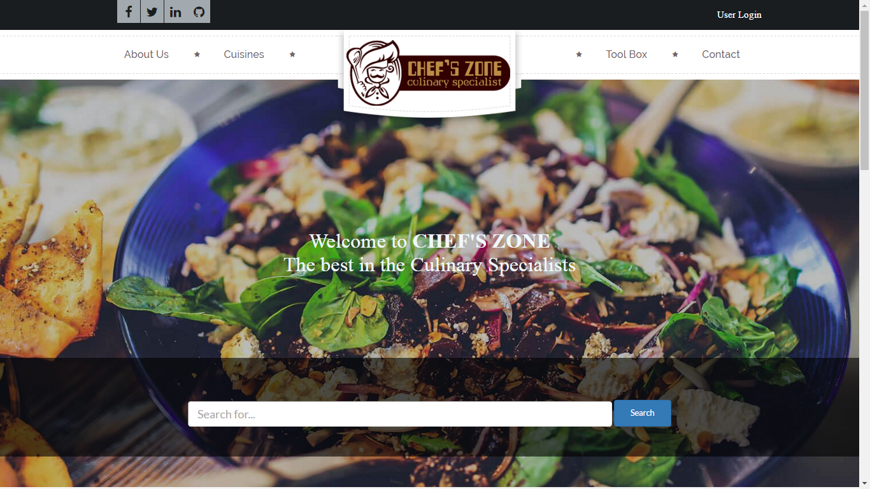

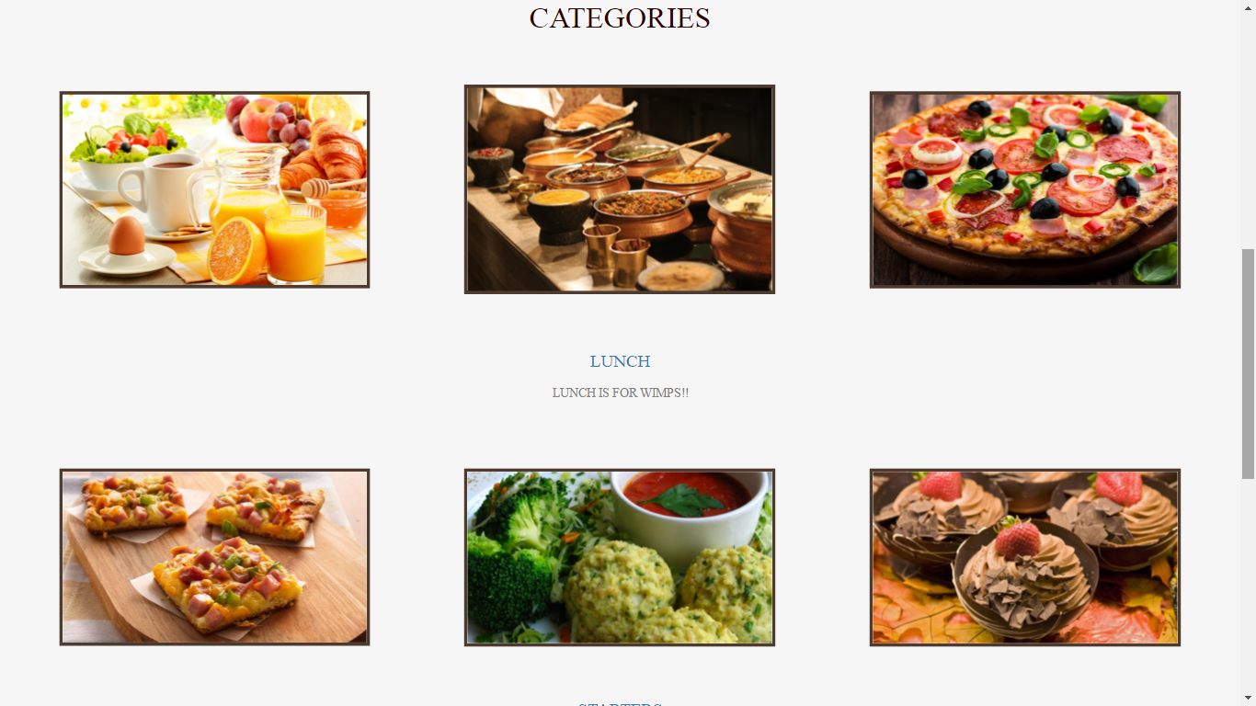

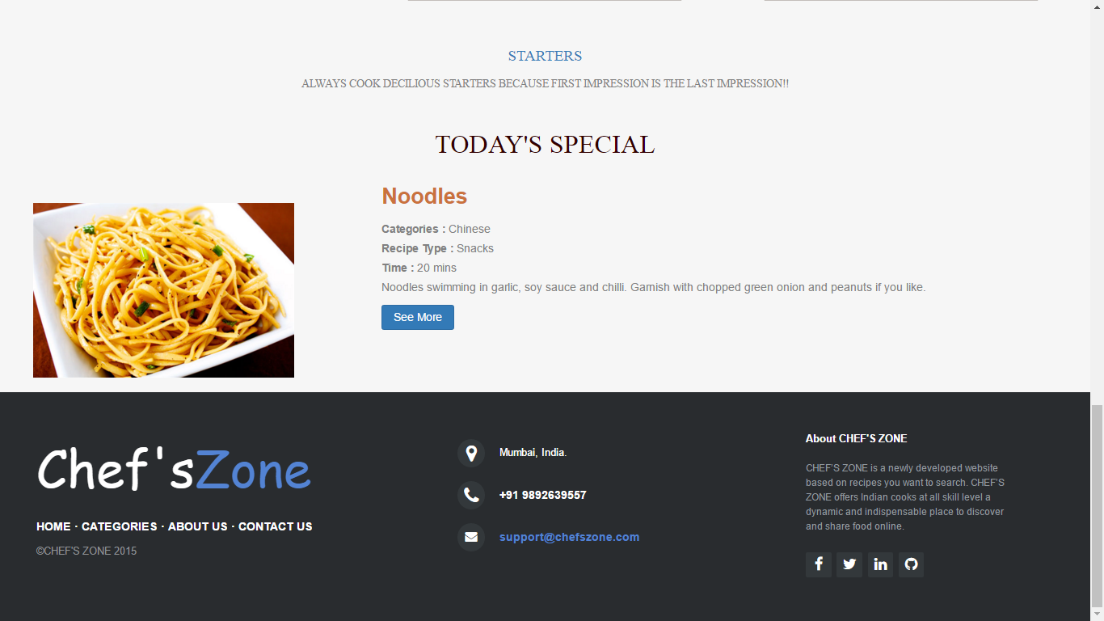

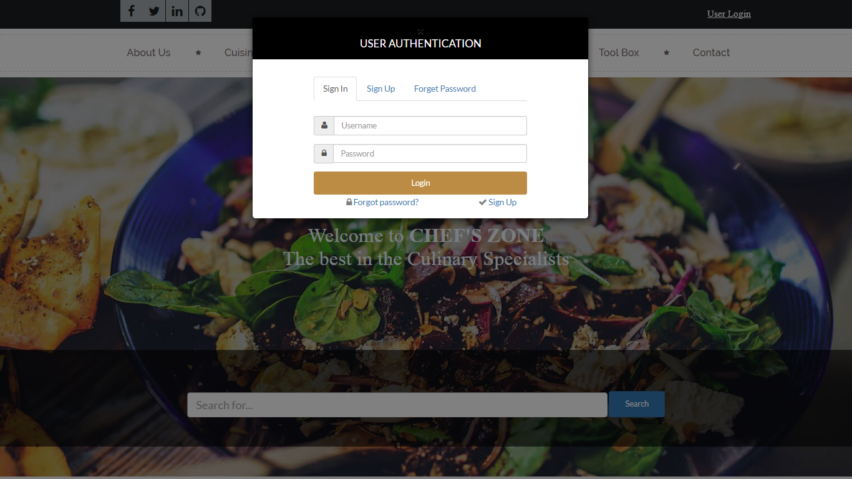

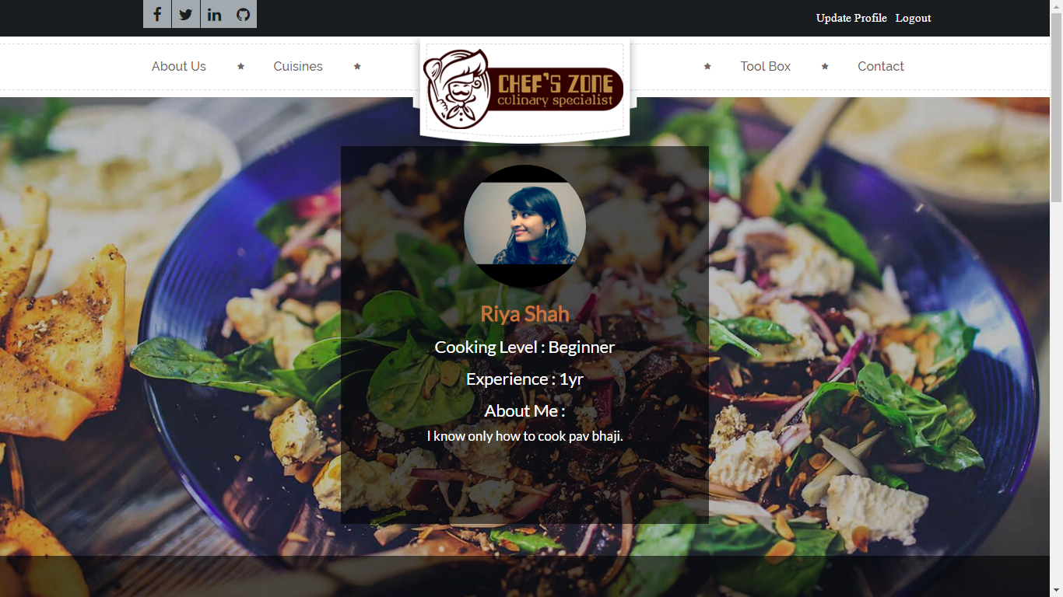

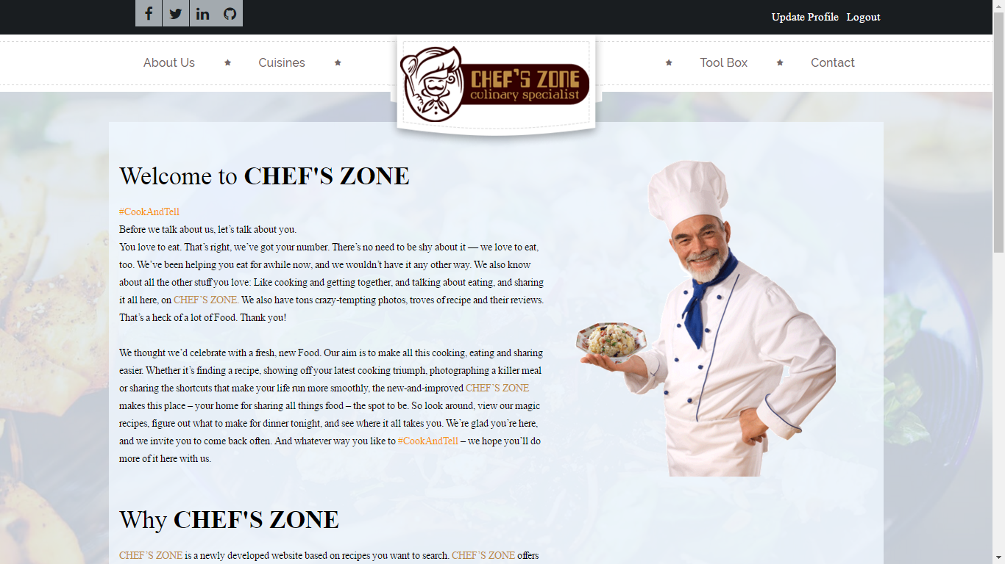

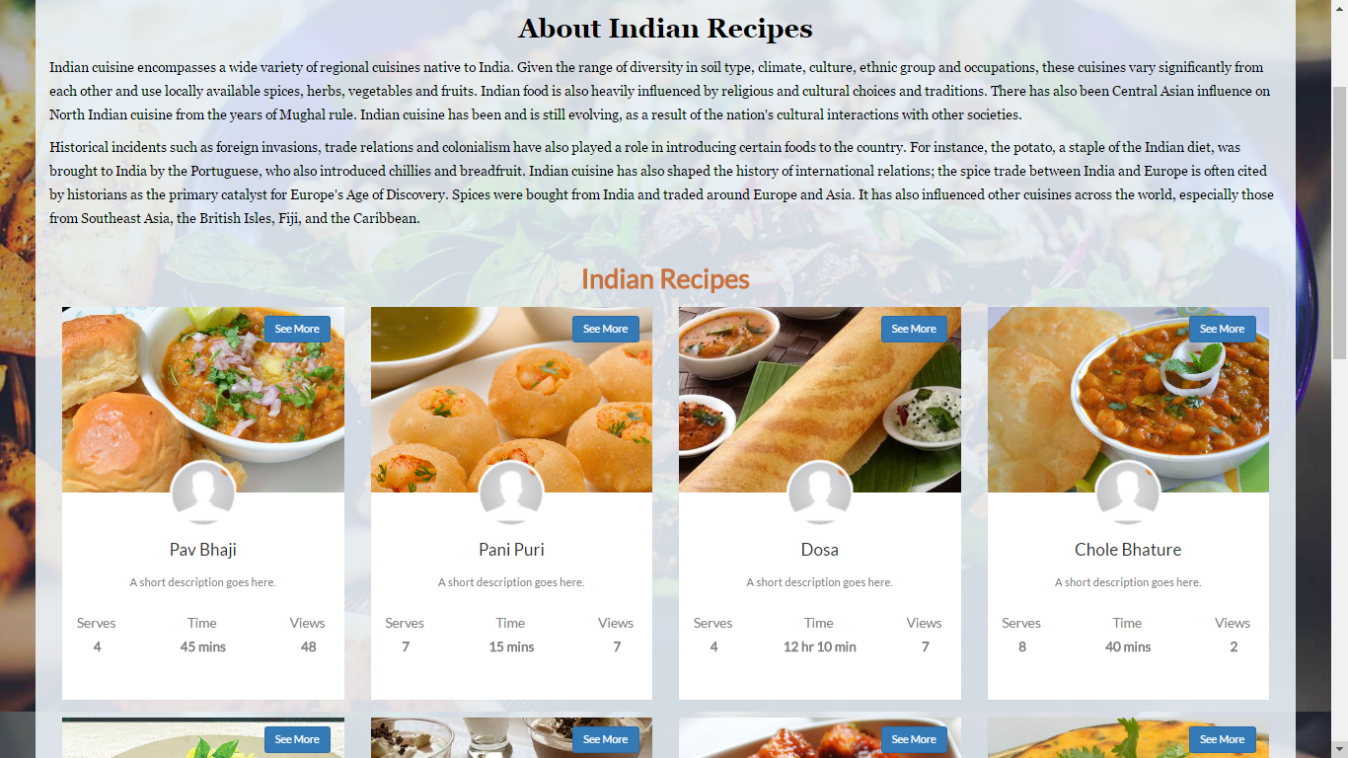

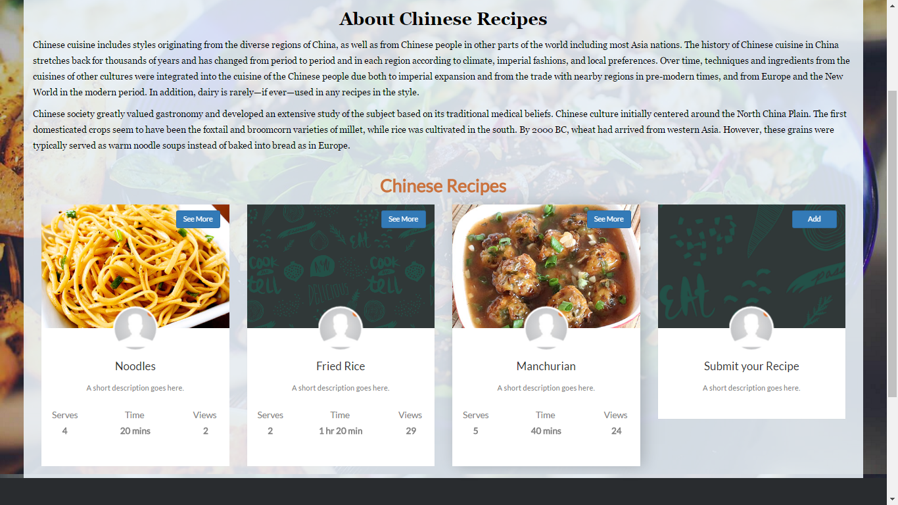

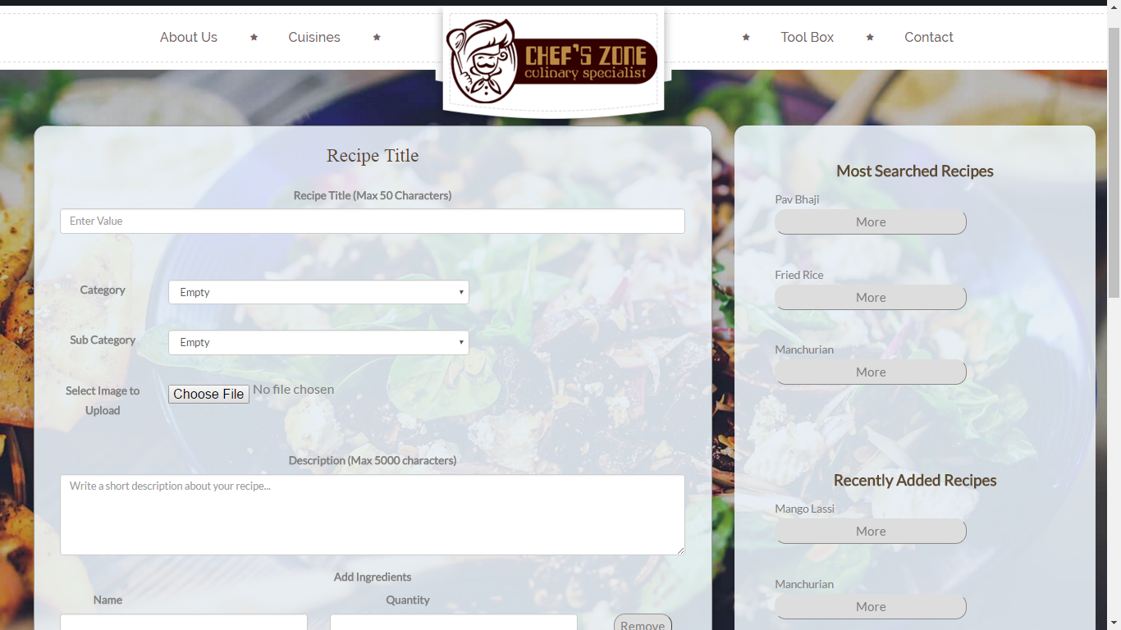

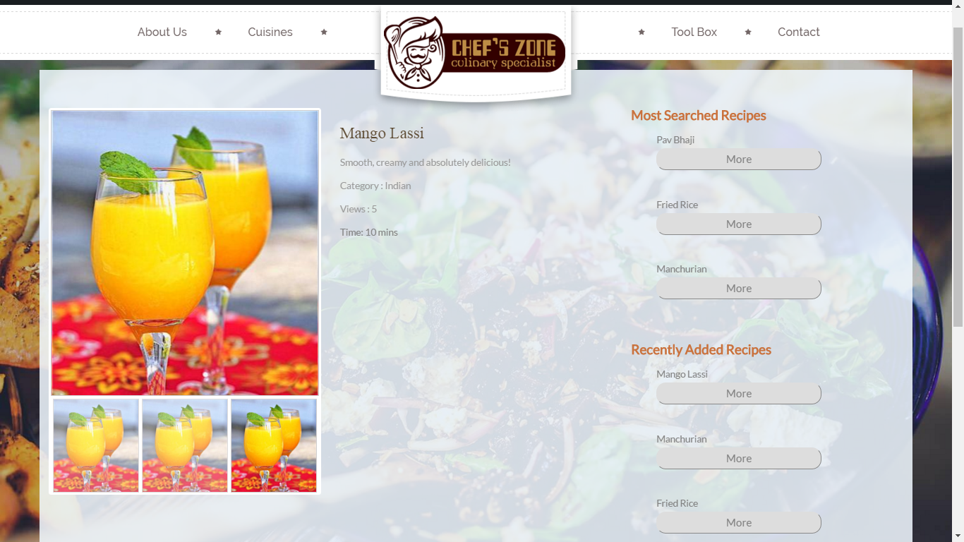

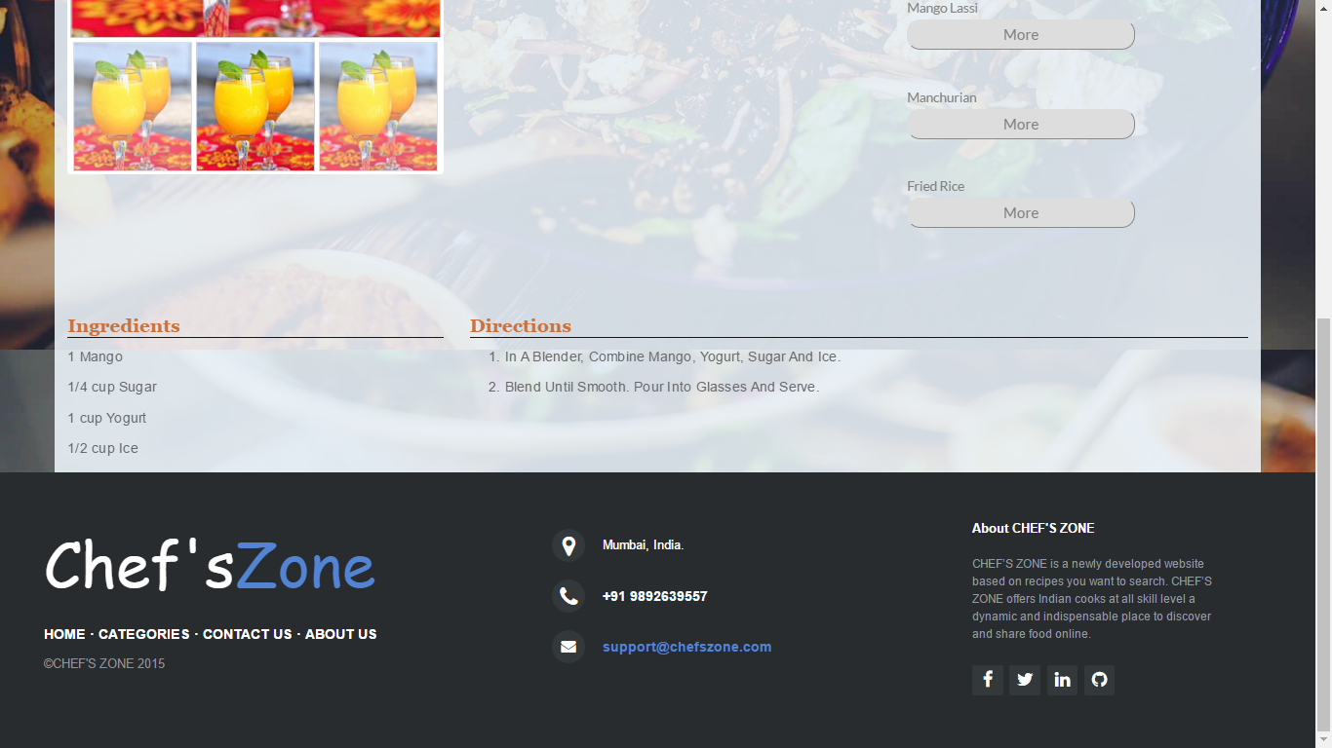

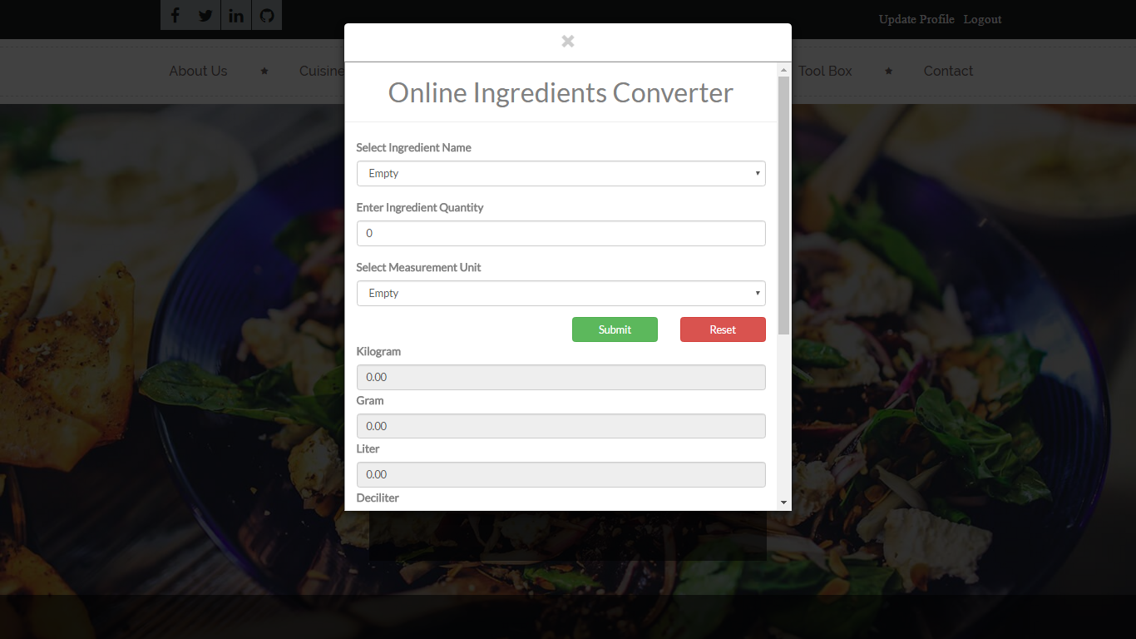

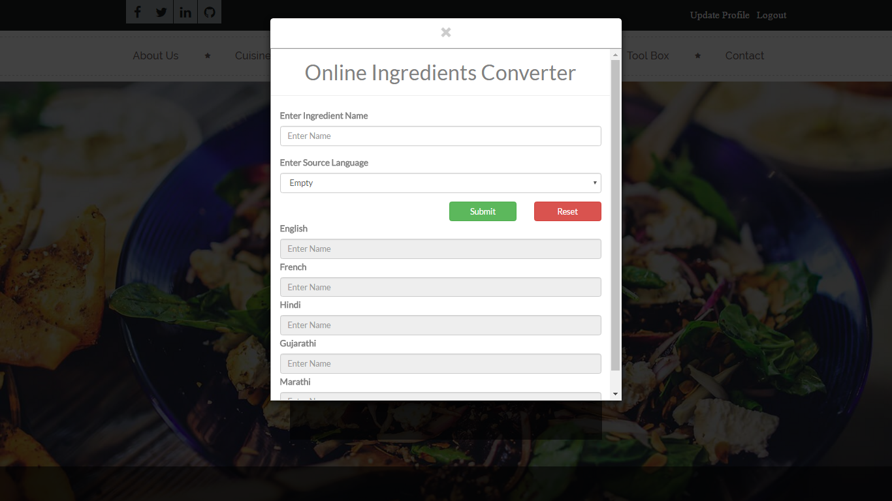

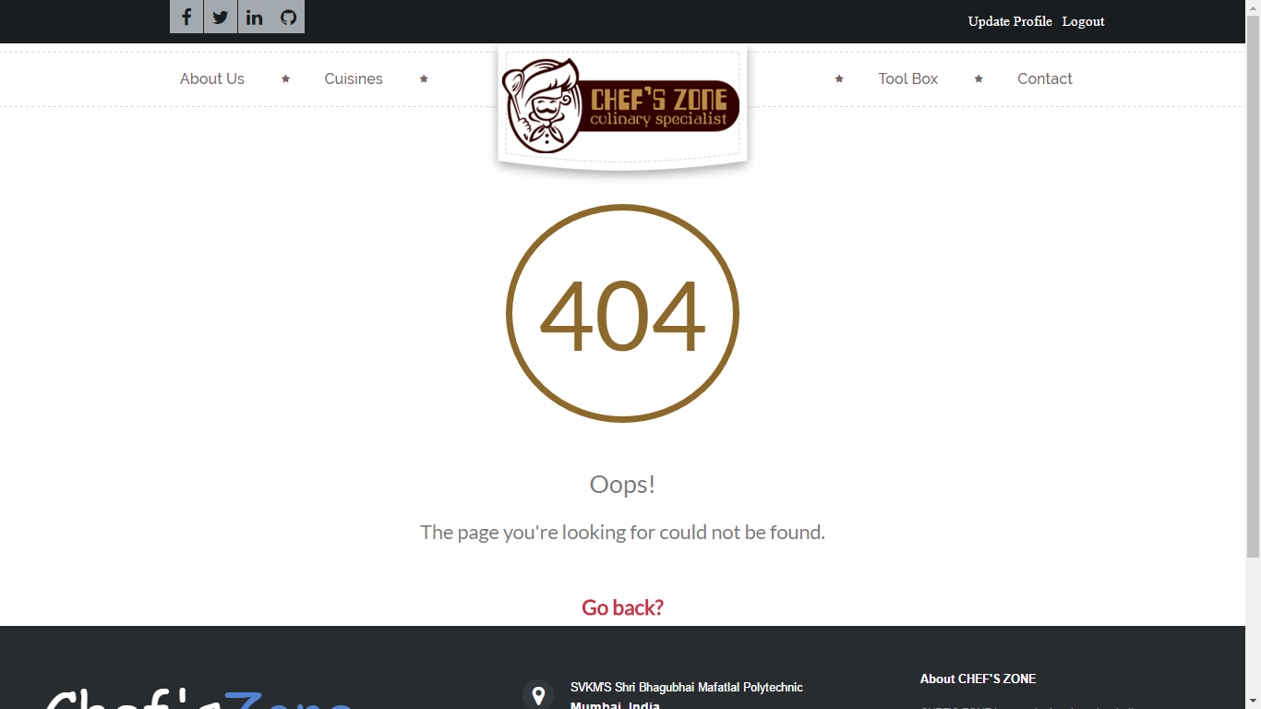

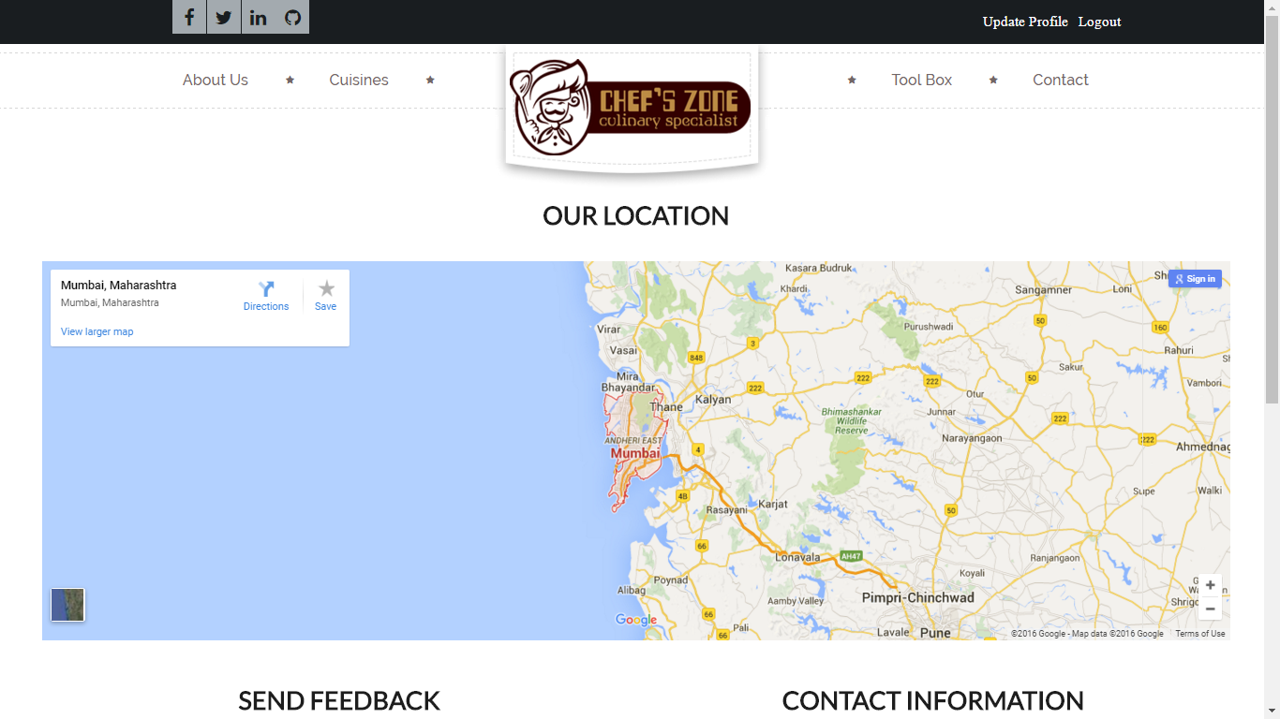

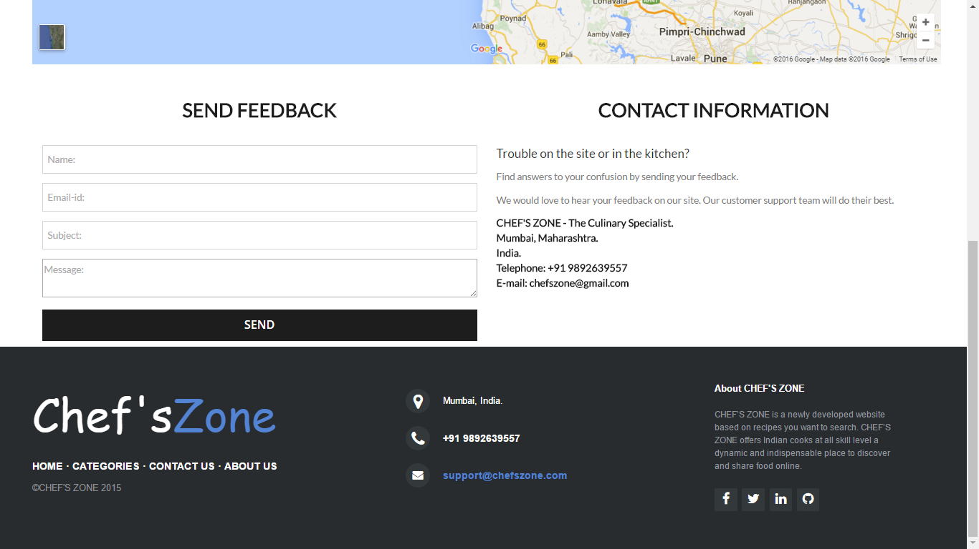



# FEASIBILTY REPORT

# 

# FEASIBILTY REPORT

Feasibility Study is a high level capsule version of the entire process intended to answer a number of questions like: **What is the problem? Is there any feasible solution to the given problem? Is the problem even worth solving?** Feasibility Study is conducted once the problem is clearly understood. Feasibility Study is necessary to determine that the proposed system is feasible by considering the Technical, Operational and Economical factors. By having a detailed Feasibility Study, the management will have a clear-cut view of the proposed system.

The following feasibilities are considered for the project in order to ensure that the project is variable and it does not have any major obstructions. Feasibility Study encompasses the following things:

## TECHNICAL FEASIBILITY.

## ECONOMIC FEASIBILITY.

## OPERATIONAL FEASIBILITY.

In this phase, we study the feasibility of all proposed systems and pick the best feasible solution for the problem. The feasibility is studied based on three main factors as follows.

## TECHNICAL FEASIBILITY:

In this step, we verify whether the proposed system are technically feasible or not i.e. all the technologies required to develop the system are readily available or not.

Technical feasibility determines whether the organization has the technology and skills necessary to carry out the project and how this should be obtained. The system can be feasible because of the following grounds:

* All necessary technology exists to develop the system.
* This system is too flexible and it can be expanded further.
* This system can give guarantees of accuracy, ease of use, reliability and the data security.
* This system can give instant response to inquire.

Our project is technically feasible because all the technology needed for our project is readily available.

| OPERATING SYSTEM: | Windows 8 |
| --- | --- |
| LANGUAGES: | PHP |
| DATABASE SYSTEM: | PhpMyAdmin |
| DOCUMENTATION TOOL: | MS-Word 2013 |

## ECONOMIC FEASIBILITY:

Economically, this project is completely feasible because it requires no extra financial investment and with respect to time, it’s completely possible to complete the given task in span of 6 months.

In this step, we verify which proposal is more economical. We compare the financial benefits of the new system with the investment. The new system is economically feasible only when the financial benefits are more than the investments and expenditure. Economic Feasibility determines whether the project goal can be within the resources limits allocated to it or not. It must determine whether it is worthwhile to process with the entire project or whether the benefits obtained from the new system are not worth the costs. Financial benefits must be equal or exceed the costs. In this issue, we should consider:

* The cost to conduct a full system investigation.
* The cost of hardware and software for the class of application being considered.
* The development tool.
* The cost of maintenance etc...

Our project is economically feasible because the cost of development is very minimal when compared to financial benefits of the application.

## OPERATIONAL FEASIBILITY:

In this step, we verify different operational factors of the proposed system like man-power, time etc. , which ever solution uses less operational resources, is the best operationally feasible solution. The solution should also be operationally possible to implement. Operational Feasibility determines if the proposed system satisfied user objectives could be fitted into the current system operation.

* The methods of processing and presentation are completely accepted by the clients since they can meet all user requirements.
* The clients have been involved in the planning and development of the system.
* The proposed system will not cause any problem under any circumstances.

Our project is operationally feasible because the time requirements and personnel requirements are satisfied. We are a team of three members and we worked on this project for three working months.



# ADVANTAGES AND DISADVANTAGES

# ADVANTAGES AND DISADVANTAGES

## ADVANTAGES:

* This project has a login page which allows only the registered user to login and thereby preventing unauthorized access.
* This website can be used to view the recipes of all categories.
* This innovative project allows users to share their recipes on the website as well as can share their reviews on particular recipes or rate that particular recipe.
* This project also consists of toolbox which contains ingredient convertor and language translation.

## DISADVANTAGES:

* The user will not be able to access the website without the internet connection.
* The website currently does not support video assistance.



# APPLICATIONS

# APPLICATIONS

* The website can be proved to be very beneficial for food lovers and for those who keep on trying new dishes daily where they can upload the recipe of what they have made and can also their experiences.
* This website can also be referred by the beginners who wish to make their careers in hotel management or any other course related to cooking.
* This website can also be used to cook anything possible from left over ingredients.



# SYSTEM SPECIFICATIONS

# SYSTEM SPECIFICATIONS

**Website is:**

## LOAD BALANCING:

Since the website contains animated images and slider and also various models, it may take few minutes to load the homepage.

## EASY ACCESSIBILITY:

The user can easily access the website and can efficiently jump from one module to the other module without any obstructions in between.

## USER FRIENDLY:

The website will be giving a very user-friendly GUI and accessibility to all the users accessing the website.

## EFFICIENT AND RELIABLE:

Maintaining all the secured data into database which will be accessible according to the user requirement without any maintenance costs and will be very efficient as compared to storing all the customer data on the spreadsheet or physically in the record books.

## EASY MAINTENANCE:

Every user will be having its own username and password for themselves so maintaining the record of each user will be easy.



# FUTURE ENHANCEMENT

# FUTURE ENHANCEMENT

* **VIDEO UPLOADING:**

The user can upload videos of their recipes to explain efficiently the method to prepare that particular recipe which helps viewer to make that recipe more effectively and efficiently.

* **NOTIFICATIONS:**

User will be notified with the recipe likes, recipe comments, newly uploaded recipe by the author the user.

* **BETTER NAVIGATION:**

Make website navigation easier by simplifying layouts, designs and also by adding interactive graphics.

* **MOBILE APPLICATION:**

Once the website is been developed, we can further focus on making an application which can run on multiple platforms.



# BIBLIOGRAPHY

# BIBLIOGRAPHY

## WEBSITES:

* **www.recipematcher.com**
* **www.w3schools.com**
* **www.bootstrap.com**
* [**www.tutorialspoint.com**](http://www.tutorialspoint.com)
* [**www.foodreference.com**](http://www.foodreference.com)
* **Video tutorials on YouTube for learning PHP and Bootstrap.**



# ABOUT US

# ABOUT US

## DEVELOPED BY:

### SAGAR UMESH PARMAR [1398026]

### AKASH KETAN SHAH [1398035]

### RIYA JATIN SHAH [1398037]

## CONTACT US AT:-

### [sagarparmar4@gmail.com](mailto:sagarparmar4@gmail.com)

### [shahakash2013@gmail.com](mailto:shahakash2013@gmail.com)

### [shahriya27021997@gmail.com](mailto:shahriya27021997@gmail.com)